68D-24.005 Sarasota County Boating Restricted Areas.
(1) For the purpose of regulating the speed and operation of vessel traffic in and adjacent to the Intracoastal Waterway within Sarasota County, Florida, the following Boating Restricted Areas are established:
(a) Idle Speed No Wake Zones –
1. Stickney Point Bridge – All waters lying within and adjacent to the Intracoastal Waterway, from shoreline to shoreline, from a line drawn perpendicular to the centerline of the Intracoastal Waterway 550 feet north of the Stickney Point Bridge to a line drawn perpendicular to the centerline of the Intracoastal Waterway 650 feet south of said bridge, as depicted in drawing A.
2. Blackburn Point Bridge – All waters lying within and adjacent to the Intracoastal Waterway, from shoreline to shoreline, from a line drawn perpendicular to the centerline of the Intracoastal Waterway 650 feet north of the Blackburn Point Bridge to a line drawn perpendicular to the centerline of the Intracoastal Waterway 500 feet south of said bridge, as depicted in drawing B.
3. Albee Road Bridge – All waters lying within and adjacent to the Intracoastal Waterway, from shoreline to shoreline, from a line drawn perpendicular to the centerline of the Intracoastal Waterway 2,500 feet north of the Albee Road Bridge to a line drawn perpendicular to the centerline of the Intracoastal Waterway 1,000 feet south of said bridge, as depicted in drawing C.
4. Hatchett Creek – All waters lying within and adjacent to the Intracoastal Waterway, from shoreline to shoreline, from a line drawn perpendicular to the centerline of the Intracoastal Waterway 2,000 feet northwest of the US Highway 41 Business) Bridge to a line drawn perpendicular to the centerline of the Intracoastal Waterway 2,000 feet southeast of said bridge, as depicted in drawing D.
5. Circus Bridge (US 41) – All waters lying within and adjacent to the Intracoastal Waterway, from shoreline to shoreline, from a line drawn perpendicular to the centerline of the Intracoastal Waterway 840 feet north of the centerline of the Circus Bridge (US 41) including the marine center boat basin to a line drawn perpendicular to the centerline of the Intracoastal Waterway 300 feet south of the centerline of said bridge, as depicted in drawing E.
6. South Venice Ferry – All waters lying within and adjacent to the Intracoastal Waterway, from shoreline to shoreline, from a line drawn perpendicular to the centerline of the Intracoastal Waterway 500 feet northwest of the South Venice Ferry Dock to a line drawn perpendicular to the centerline of the Intracoastal Waterway 900 feet southeast of said dock, as depicted in drawing F.
7. Siesta Key Bridge – All waters lying within and adjacent to the Intracoastal Waterway, from shoreline to shoreline, from a line drawn perpendicular to the centerline of the Intracoastal Waterway 300 feet north of the centerline of the Siesta Key Bridge to a line drawn perpendicular to the centerline of the Intracoastal Waterway 300 feet south of the centerline of the Siesta Key Bridge, as depicted in drawing G.
8. Manasota Beach Bridge – All waters lying within and adjacent to the Intracoastal Waterway, from shoreline to shoreline, from a line drawn perpendicular to the centerline of the Intracoastal Waterway 300 feet north of the centerline of the Manasota Beach Bridge to a line drawn perpendicular to the centerline of the Intracoastal Waterway 300 feet south of the centerline of the Manasota Beach Bridge, as depicted in drawing H.
(b) Sarasota County shall install and maintain appropriate regulatory markers as directed by the Division of Law Enforcement within such boating restricted areas.
(2) The boating restricted areas described in subsection 68D-24.005(1), F.A.C., are depicted on the following drawings:
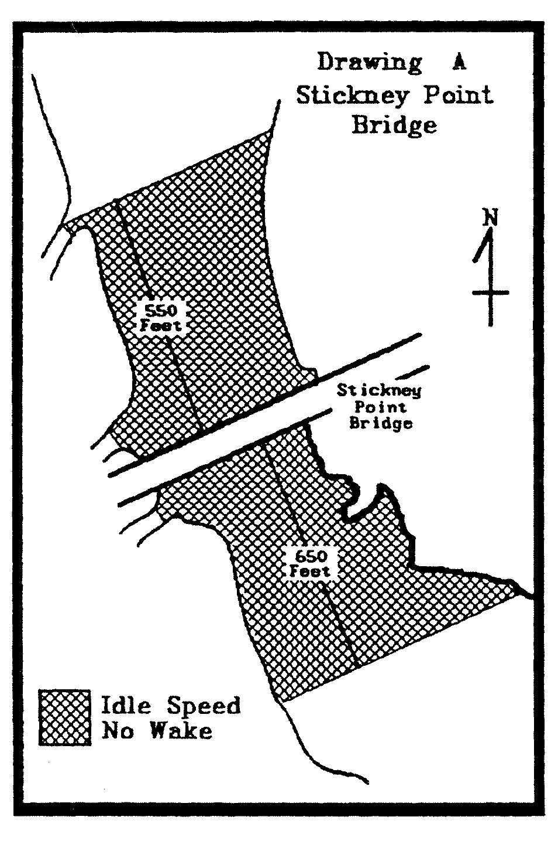 | 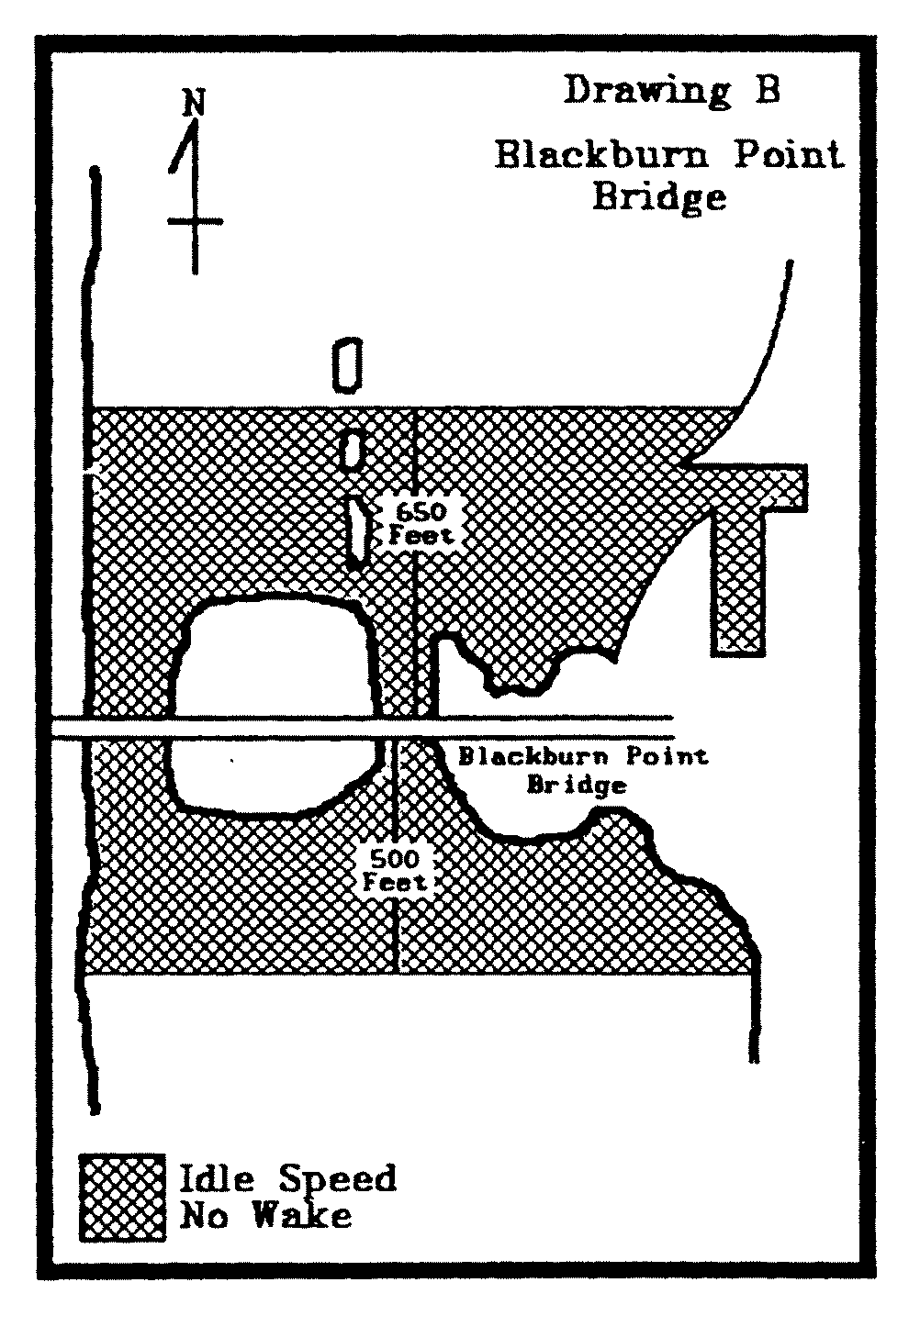
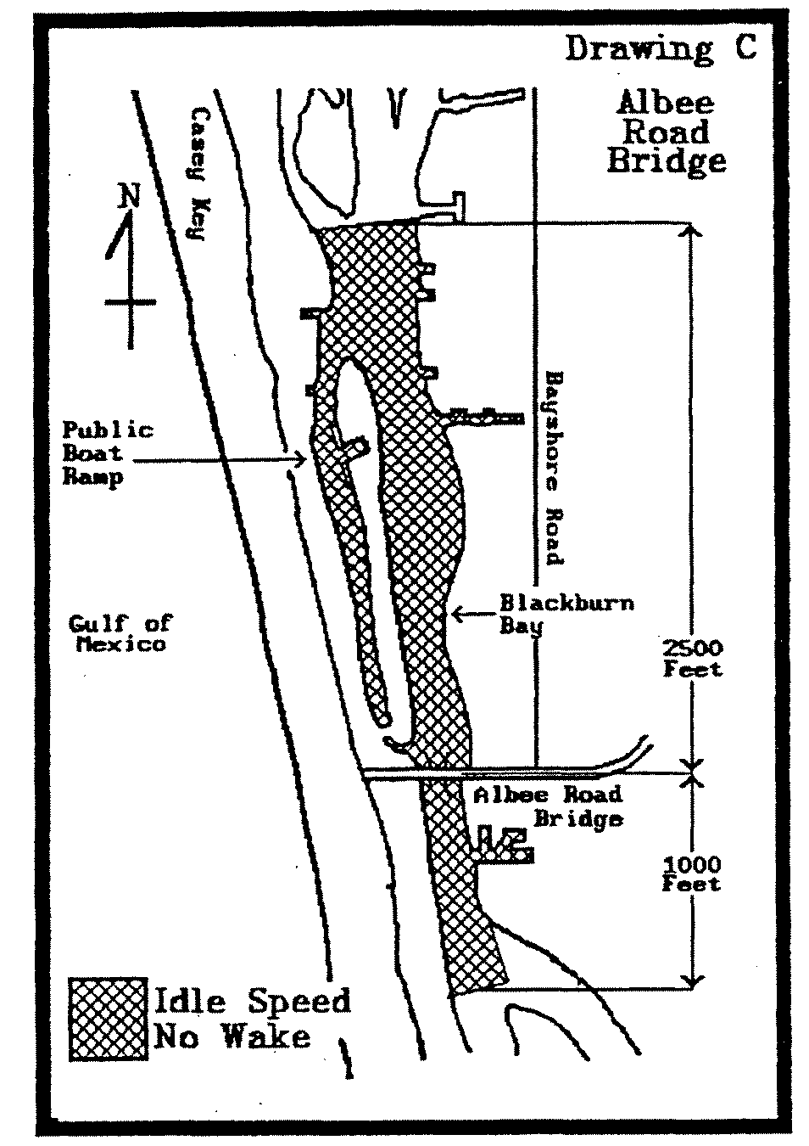

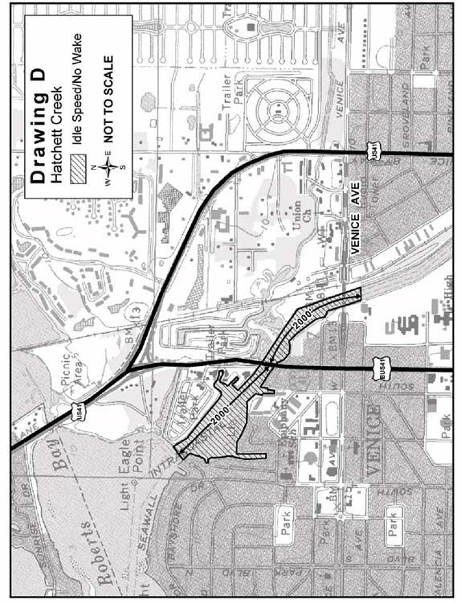
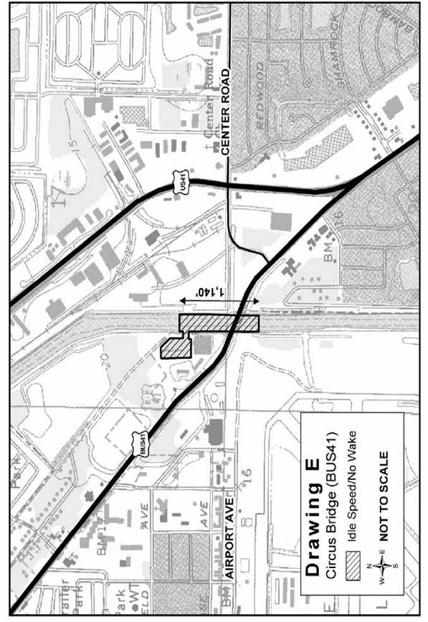
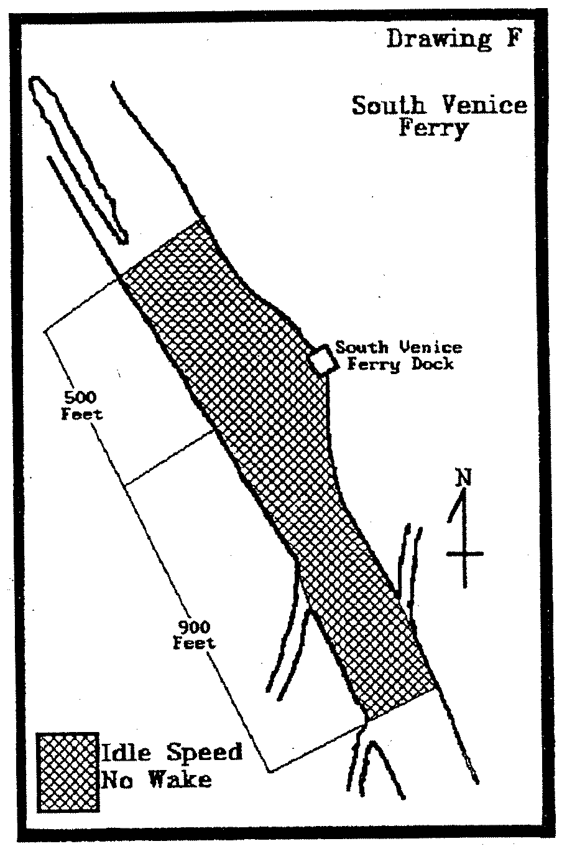
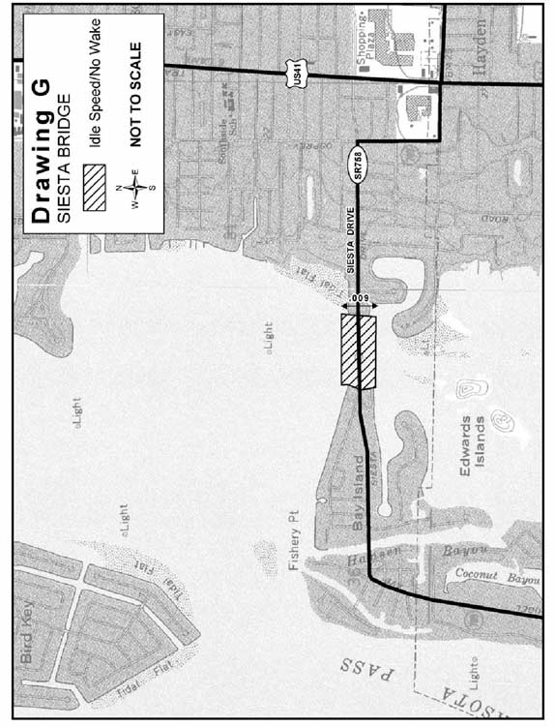
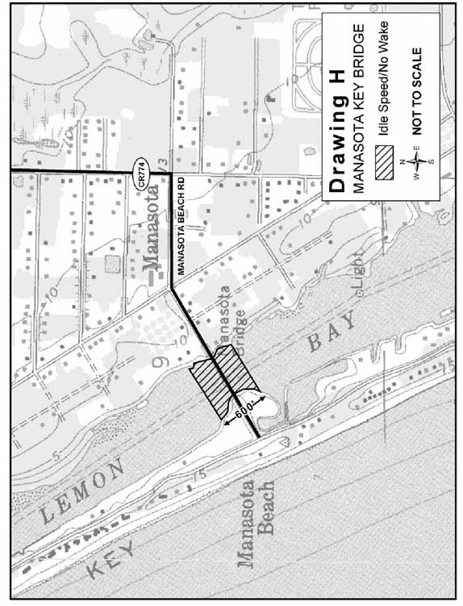
Rulemaking Authority 327.04, 327.46 FS. Law Implemented 327.46 FS. History–New 8-30-83, Formerly 16N-24.05, Amended 12-21-92, Formerly 16N-24.005, 62N-24.005, Amended 1-1-06.

