68C-22.016 Pinellas County Zones.
(1) The Commission hereby designates the waters within Pinellas County, as described below, as areas where manatee sightings are frequent and where the best available information supports the conclusion that manatees inhabit these areas on a regular or periodic basis. The primary purpose of this rule is to protect manatees from harmful collisions with motorboats and from harassment byregulating the speed and operation of motorboats within these designated areas. A secondary purpose is to protect manatee habitat. In consideration of balancing the rights of fishers, boaters, and water skiers to use the waters of the state for recreational and commercial purposes (as applicable under Section 370.12(2)(k), FS., with the need to provide manatee protection, the Commission has examined the need for limited lanes, corridors, or unregulated areas that allow higher speeds through or within regulated areas. Such lanes, corridors, or areas are provided in those locations where the Commission determined that they are consistent with manatee protection needs.
(2) The following seasonal SLOW SPEED (April 1 – November 15) zones are established, which include all associated and navigable tributaries, lakes, creeks, coves, bends, backwaters, canals, and boat basins unless otherwise designated or excluded.
(a) Safety Harbor Area: All waters inshore of a line beginning at a point (approximate latitude 28° 0' 8.0" North, approximate longitude 82° 40' 43.4" West) on the western shoreline of Old Tampa Bay, then bearing 81.1° for a distance of approximately 1642 feet to a point (approximate latitude 28°0'10.8" North, approximate longitude 82°40'25.3" West) in the water, then bearing 13.9° for a distance of approximately 1242 feet to a point (approximate latitude 28° 0' 22.8" North, approximate longitude 82° 40' 22.2" West) in the water, then bearing 334.5° for a distance of approximately 1054 feet to a point (approximate latitude 28° 0' 32.1" North, approximate longitude 82° 40' 27.4" West) in the water, then bearing 324.2° for a distance of approximately 2911 feet to a point (approximate latitude 28° 0' 55.0" North, approximate longitude 82° 40' 46.8" West) in the water, then bearing 333.8° for a distance of approximately 1973 feet to a point (approximate latitude 28° 1' 12.6" North, approximate longitude 82° 40' 56.7" West) in the water, then bearing 349.1° for a distance of approximately 1645 feet to a point (approximate latitude 28° 1' 28.6" North, approximate longitude 82° 41' 0.4" West) in the water, then bearing 42.7° for a distance of approximately 1561 feet to a point (approximate latitude 28° 1' 40.0" North, approximate longitude 82° 40' 48.9" West) in the water, then bearing 80.1° for a distance of approximately 2130 feet to a point (approximate latitude 28° 1' 44.0" North, approximate longitude 82° 40' 25.5" West) in the water, then bearing 102.0° for a distance of approximately 905 feet to a point (approximate latitude 28° 1' 42.4" North, approximate longitude 82° 40' 15.6" West) in the water, then bearing 140.5° for a distance of approximately 1280 feet to a point (approximate latitude 28° 1' 32.5" North, approximate longitude 82° 40' 6.3" West) in the water, then bearing 173.2° for a distance of approximately 636 feet to a point (approximate latitude 28° 1' 26.2" North, approximate longitude 82° 40' 5.4" West) in the water, then bearing 191.4° for a distance of approximately 1748 feet to a point (approximate latitude 28° 1' 9.2" North, approximate longitude 82° 40 '8.9" West) in the water, then bearing 202.3° for a distance of approximately 553 feet to a point (approximate latitude 28° 1' 4.2" North, approximate longitude 82° 40' 11.2" West) in the water, then bearing 184.2° for a distance of approximately 1033 feet to a point (approximate latitude 28° 0' 54.0" North, approximate longitude 82° 40' 12.0" West) in the water, then bearing 169.2° for a distance of approximately 702 feet to a point (approximate latitude 28° 0' 47.1" North, approximate longitude 82° 40' 10.3" West) in the water, then bearing 144.1° for a distance of approximately 716 feet to a point (approximate latitude 28° 0' 41.5" North, approximate longitude 82° 40' 5.6" West) in the water, then bearing 165.5° for a distance of approximately 1606 feet to a point (approximate latitude 28° 0' 26.2" North, approximate longitude 82° 40' 0.9" West) in the water, then bearing 175.3° for a distance of approximately 1202 feet to a point (approximate latitude 28° 0' 14.4" North, approximate longitude 82° 39' 59.5" West) in the water, then bearing 89.8° for a distance of approximately 877 feet to the line’s terminus at a point on the eastern shoreline of Safety Harbor. The northwestern boundary is the centerline of the SR 580 Bridge.
(b) North of Courtney Campbell Causeway: All waters inshore of a line beginning at a point (approximate latitude 27° 57' 46.1" North, approximate longitude 82° 41' 8.4" West) on the northern shoreline of the Courtney Campbell Causeway, then bearing 14.4° for a distance of approximately 2827 feet to a point (approximate latitude 27° 58' 13.2" North, approximate longitude 82° 41' 0.9" West) in the water, then bearing 29.7° for a distance of approximately 1995 feet to a point (approximate latitude 27° 58' 30.4" North, approximate longitude 82° 40' 50.1" West) in the water, then bearing 353.8° for a distance of approximately 442 feet to a point (approximate latitude 27° 58' 34.8" North, approximate longitude 82° 40' 50.9" West) in the water, then bearing 317.1° for a distance of approximately 927 feet to a point (approximate latitude 27° 58' 41.6" North, approximate longitude 82° 40' 57.9" West) in the water, then bearing 351.7° for a distance of approximately 1164 feet to a point (approximate latitude 27° 58' 52.8" North, approximate longitude 82° 41' 0.1" West) in the water, then bearing 344.8° for a distance of approximately 1677 feet to a point (approximate latitude 27° 59' 8.9" North, approximate longitude 82° 41' 5.0" West) in the water, then bearing 6.5° for a distance of approximately 678 feet to a point (approximate latitude 27° 59' 15.4" North, approximate longitude 82° 41' 4.4" West) in the water, then bearing 36.4° for a distance of approximately 2905 feet to a point (approximate latitude 27° 59' 39.0" North, approximate longitude 82° 40' 45.4" West) in the water, then bearing 38.3° for a distance of approximately 1504 feet to a point (approximate latitude 27° 59' 50.8" North, approximate longitude 82° 40' 35.3" West) in the water, then bearing 31.0° for a distance of approximately 1363 feet to a point (approximate latitude 28° 0' 2.3" North, approximate longitude 82° 40' 27.5" West) in the water, then bearing 14.7° for a distance of approximately 869 feet to a point (approximate latitude 28° 0' 10.8" North, approximate longitude 82° 40' 25.3" West) in the water, then bearing 261.1° to the line’s terminus at a point (approximate latitude 28° 0' 8.0” North, approximate longitude 82° 40' 43.4” West) on the western shoreline of Old Tampa Bay.
(3) The zones described in subsection 68C-22.016(2), F.A.C., are depicted on the following map, labeled “Pinellas County Manatee Protection Zones.” The map is intended to depict the above-described zones. In the event of conflict between the map and descriptions, the descriptions shall prevail.
(4) Rule 68C-22.016, F.A.C., as approved by the Commission on September 22, 2004, shall take effect as soon as the regulatory markers are posted.
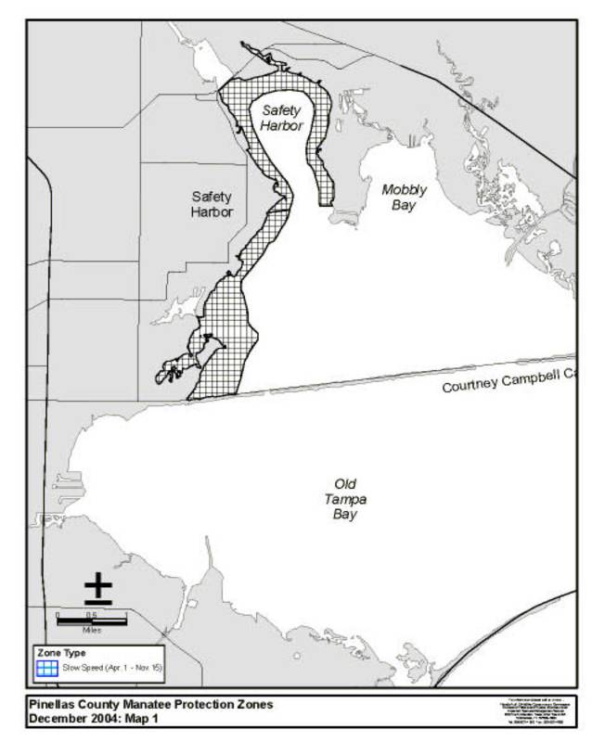
Rulemaking Authority 370.12(2)(n) FS. Law Implemented 370.12(2)(d), (k), (n) FS. History–New 1-5-05.

