40D-8.626 Minimum Aquifer Levels.
(1) Hillsborough County North of State Road 60, and Pasco and Pinellas Counties Salt Water Intrusion within this area has not been regional in nature, but is of localized concern in some coastal areas. The District has chosen the North Pinellas, Southwest Pasco and Northwest Hillsborough Counties region as the priority area for the establishment of Salt Water Intrusion Minimum Aquifer Levels (“SWIMAL”) to prevent regional seawater intrusion because of the availability of data and the potential for future intrusion. The SWIMALs for the Upper Floridan aquifer shall be established as follows:
(a) The location of the SWIMAL sites serves to monitor the area where early signs of regional salt water intrusion can best be detected.
(b) The SWIMALs shall be established by setting levels in coastward transects of wells whose potentiometric levels define the Long-term average hydraulic gradient of the Upper Floridan aquifer potentiometric surface.
(c) The Salt Water Intrusion Minimum Aquifer Levels are as set forth in the following table. Aquifer levels are deemed to be below the SWIMAL when the Long-term average elevation is below the SWIMAL.
TABLE 8-4 SALT WATER INTRUSION
MINIMUM AQUIFER LEVELS
Well Name | Saltwater Intrusion Minimum Aquifer Level (feet NGVD)
Sheldon Road Deep (RMP-16D) | 7.7
RMP-13D | 16.4
RMP-8D1 | 26.8
Tarpon Rd. Deep | 9.9
SWI-18S | 14.8
201-M | 13.7
EW 2S Deep | 10.3
(2) SWUCA Salt Water Intrusion Minimum Aquifer Level.
(a) The District has determined that ground water withdrawals in the SWUCA have contributed to water level declines that advance saltwater intrusion. The coastal portion of the SWUCA in southern Hillsborough, Manatee and northern Sarasota counties (the Most Impacted Area or MIA) is a priority area for the establishment of minimum aquifer levels because of its proximity to the saltwater interface and the large effect on interface movement caused by lowering of the potentiometric surface in this area. The Salt Water Intrusion Minimum Aquifer Level (SWIMAL) is established to stabilize regional water level declines so that long-term management efforts can slow the rate of regional saltwater intrusion in the MIA. This is based on an average value to address the regional nature of the problem and avoids the potential for localized lowering of a minimum level.
(b) The SWIMAL over the surface of the MIA is 13.1 feet (National Geodetic Vertical Datum of 1929 or NGVD 1929). The SWIMAL is derived using the method set forth in paragraph (2)(c) below.
(c) The reference period for which the SWIMAL is calculated is the period 1990 through 1999. Ten wells from within or adjacent to the MIA (Table 8-5), are used to determine the minimum level. The annual average elevation for each of the years 1990 through 1999 is established utilizing monthly water level data for each of the wells. The annual averages over the period are then used to calculate the decadal average for the period. The 1990-99 average Upper Floridan aquifer potentiometric surface of the MIA is constructed by calculating the average of these annual average values weighted spatially using the Thiessen polygon methodology. The resulting Minimum Level over the surface of the MIA is 13.1 feet (National Geodetic Vertical Datum of 1929).
Table 8-5: Wells utilized to determine the Salt Water Intrusion Minimum Aquifer Level.
Site
Number | Sequence Number | Site Name
564 | 0 | KIBLER DEEP
87 |  | ROMP 123 Hawthorn/Ocala  HAWTHORN/OCALA
10914 | 0 | ROMP 50 TAMPA/OCALA
10883 | 0 | ROMP TR 10-2 TAMPA
287 | 0 | ROMP TR 7-1 TAMPA
10926 | 0 | ROMP TR 7-4  Suwannee/Ocala  SUWANNEE/OCALA
10920 | 0 | ROMP TR 8-1 Upper Avon  Park  PARK
10909 | 1 | ROMP TR 9-3 Ocala/Avon  Park
561 | 0 | SARASOTA 9 DEEP
456 | 0 | VERNA T 0-4
(d) Implementation of The SWUCA Salt Water Intrusion Minimum Aquifer Level – The SWIMAL shall be used to gauge the status of the ground water resource with respect to saltwater intrusion in the region. Determining the status of the rate of movement of the saltwater interface shall be based on comparison of the average Floridan aquifer water level over the MIA with the Floridan aquifer minimum level over ten-year moving windows of time. The ten-year average water level for a particular year shall be calculated as the average water level for that year and the previous nine years. The process of calculating the ten-year average is the same as described in paragraph (c), above, for calculating the minimum level.
(e) Compliance – The objective of the District’s management efforts is for the ten-year moving annual average water level to fluctuate in a range at or above the minimum level. The minimum level is achieved if the ten-year moving annual average water level has fluctuated at or above the minimum level for a minimum of five consecutive years. Once the minimum level is achieved, the minimum level is no longer met when the ten-year moving annual average water level falls below the minimum level for more than two consecutive years. Then, the five consecutive years above the minimum level is again required for compliance.
(3) Dover/Plant City Water Use Caution Area Minimum Aquifer Level.
(a) The District has determined that groundwater withdrawals in the Dover/Plant City area have contributed to water level declines that are significantly harmful to the water resources of the area. The Minimum Aquifer Level is established as part of a comprehensive management program intended to arrest water level declines during frost/freeze events to minimize the potential for impacts to existing legal uses and sinkhole occurrence.
(b) The Minimum Aquifer Level is the 10 ft. potentiometric surface elevation (NGVD 1929) at District Well DV-1 Suwannee, located as shown in Figure 8-4. The Minimum Aquifer Level is the level below which the greatest impact occurred in terms of well failures and sinkholes during the 2010 frost/freeze event.
(c) To address the effects of local and regional groundwater withdrawals and the variable hydrogeologic factors within the region, a Minimum Aquifer Level Protection Zone is established. The Minimum Aquifer Level Protection Zone is the area within the 30 ft. drawdown contour that resulted from the January, 2010 frost/freeze event, as shown in Figure 8-4.
(d) Compliance with the Minimum Aquifer Level is evaluated annually using a groundwater flow model simulation of a frost/freeze event and the effects of the event on aquifer water levels in the Dover/Plant City Water Use Caution Area. If the resulting potentiometric level is at or above 10 ft. (NGVD 29) at District Well DV-1 Suwannee, the Minimum Aquifer Level is met. If the resulting level is below 10 ft. (NGVD 1929) at District Well DV-1 Suwannee, the Minimum Aquifer Level is not met.
Figure 8-4. Minimum Aquifer Level District Well DV-1 Suwannee and Minimum Aquifer Level Protection Zone
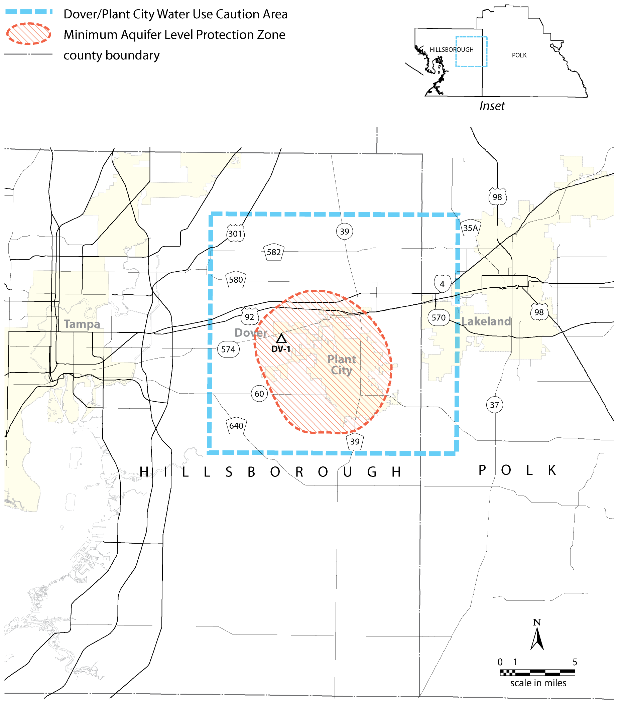
Rulemaking Authority 373.044, 373.113, 373.171 FS. Law Implemented 373.036, 373.042, 373.0421, 373.709 FS. History–New 8-7-00, Amended 1-1-07, 6-16-11, 2-17-22.

