40E-22.332 Water Shortage Triggers.
(1) Water shortage trigger levels for Lake Okeechobee are shown on Figure 22-4. When water levels within Lake Okeechobee fall below these trigger levels, the Governing Board may impose water shortage restrictions pursuant to Rules 40E-21.231, 40E-8.441, F.A.C., and this Part. In considering declaring a water shortage, the Governing Board shall consider other factors evaluated in this Part and Rule 40E-21.221, F.A.C., along with these trigger levels.
(2)(a) When water levels within Lake Okeechobee fall within “Zone A” depicted on Figure 22-4, a Phase I water shortage may be declared within the service area, pursuant to Rule 40E-21.521, F.A.C.
(b) When water levels within Lake Okeechobee fall within “Zone A” area depicted on Figure 22-4, and can be expected to reach a June 1st lake stage of 10.5 feet NGVD, a Phase II water shortage may be declared within the service area pursuant to Rule 40E-21.531, F.A.C.
(c) When water levels within Lake Okeechobee fall below, or can be expected to fall below the June 1st lake stage of 10.5 feet NGVD, a Phase III or greater water shortage may be declared within the service area pursuant to Rule 40E-21.541, F.A.C.
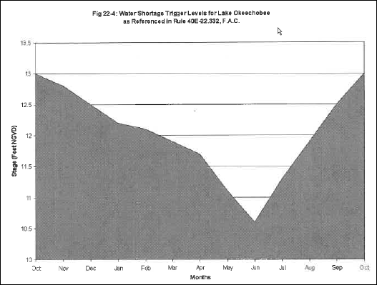
Rulemaking Authority 373.044, 373.113 FS. Law Implemented 373.042, 373.0421, 373.086, 373.103(4), 373.175, 373.246 FS. History–New 9-10-01.

