68D-24.020 Suwannee and Santa Fe River Boating Restricted Areas.
(1) For the purpose of regulating the speed and operation of vessel traffic, the Suwannee and Santa Fe River Boating Restricted Areas are established as follows:
Idle Speed No Wake Zones.
(a) All waters in and adjacent to the Suwannee River from the centerline of the US 90 Bridge at Ellaville south to the centerline of the SR 51 Bridge at Luraville, in effect when the Suwannee River level is forty-seven feet (47') (MSL) or higher as indicated on the Ellaville gauge, as depicted in Drawing A.
(b) All waters in and adjacent to the Suwannee River from the centerline of the SR 51 Bridge at Luraville to a line drawn perpendicular to the centerline of the Suwannee River at Little River Spring, in effect when the Suwannee River level is twenty-six feet (26') (MSL) or higher as indicated on the Branford gauge, as depicted in Drawing B.
(c) All waters in and adjacent to the Suwannee River from a line drawn perpendicular to the centerline of the Suwannee River at Little River Spring to the centerline of the C.R. 340 Bridge at Rock Bluff, in effect when the Suwannee River level is twenty-four feet (24') (MSL) or higher as indicated on the Branford gauge, as depicted in Drawing C.
(d) All waters in and adjacent to the Suwannee River from the centerline of the C.R. 340 Bridge at Rock Bluff to a line drawn perpendicular to the centerline of the Suwannee River one mile south of the Fowler Bluff Boat Ramp when the Suwannee River level is nine feet (9') (MSL) or higher as indicated on the Wilcox gauge, as depicted in Drawing D.
(e) All waters in and adjacent to the Santa Fe River from a line drawn perpendicular to the centerline of the Santa Fe River at River Rise in O’Leno State Park westerly to the confluence of the Suwannee and Santa Fe Rivers, in effect when the Santa Fe River is seventeen feet (17') (MSL) or higher as indicated on the Three Rivers Estates gauge, as depicted in Drawing E.
(2) When in Effect – The boating restricted areas established in subsection (1) shall be active and enforceable only when the water levels are as specified in each paragraph. For purposes of this rule, all referenced river levels are in feet above mean sea level (MSL), 1929 National Geodetic Vertical Datum.
(3) The boating restricted areas described in Rule 68D-24.020, F.A.C., are depicted in the following drawings:

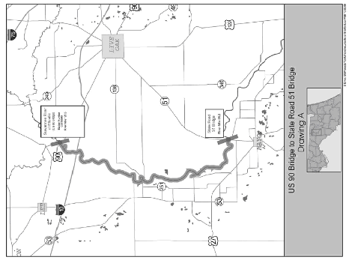

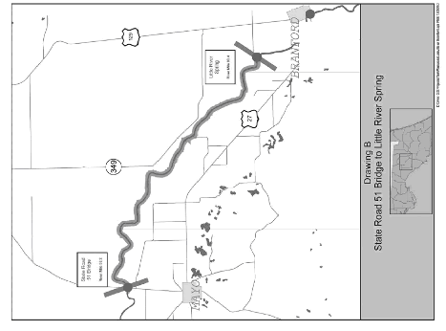

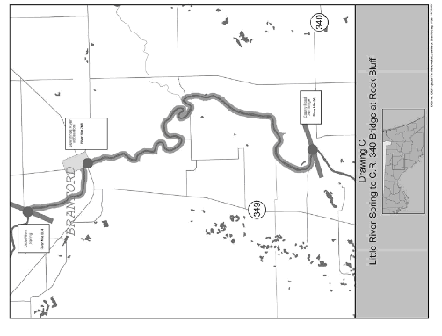

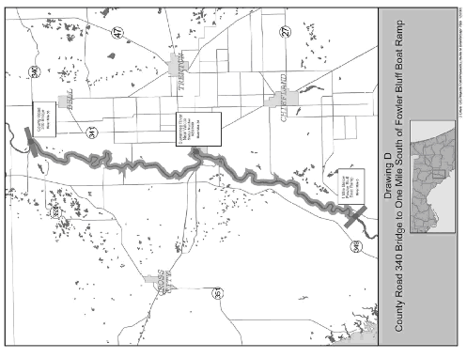

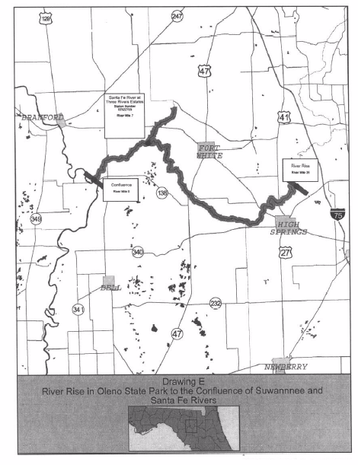
Rulemaking Authority 327.04, 327.46 FS. Law Implemented 327.46 FS. History–New 5-3-94, Formerly 16N-24.020, 62N-24.020, Amended 3-16-06.

