68D-24.018 St. Johns River Boating Restricted Areas.
(1) For the purpose of regulating the speed and operation of vessel traffic on the St. Johns River in Lake, Seminole and Volusia Counties, the following Boating Restricted Areas are established:
(a)1. Lake George Fender System: An Idle Speed No Wake boating restricted area within the fender system and associated channel at the south end of Lake George from a line drawn perpendicular to the centerline of the channel at the north end of the fender system to a line drawn perpendicular to the centerline of the channel 1,500 feet south and southeast of the south end of the fender system, as depicted in Drawing A.
2. South Moon Canal:
a. An Idle Speed No Wake boating restricted area from shoreline to shoreline in the St. Johns River and all waters of South Moon Canal, from a line drawn perpendicular to the centerline of the St. Johns River 50 feet north of the confluence of South Moon Canal and the St. Johns River to a line drawn perpendicular to the centerline of the river 850 feet south of said confluence, as depicted in Drawing B.
b. During flooding, an Idle Speed No Wake boating restricted area from shoreline to shoreline in the St. Johns River, from a line drawn perpendicular to the centerline of the St. Johns River 850 feet south of the confluence of South Moon Canal and the St. Johns River approximately 3,000 feet south to a line drawn perpendicular to the centerline of the St. Johns River 50 feet northwest of the confluence of the Jungle Den Canal, as depicted in Drawing B, to be in effect and enforceable when the St. Johns River level is 2.8 feet or higher as indicated by the St. Johns River Water Management District gauge at the S. R. 40 Bridge in Astor.
3. Jungle Den Canal:
a. An Idle Speed No Wake boating restricted area from shoreline to shoreline in the St. Johns River and all waters of the Jungle Den Canal, from a line drawn perpendicular to the centerline of the St. Johns River 50 feet northwest of the confluence of Jungle Den Canal and the St. Johns River to a line drawn perpendicular to the centerline of the river 1,050 feet south of said confluence, as depicted in Drawing C.
b. During flooding an Idle Speed No Wake boating restricted area from shoreline to shoreline in the St. Johns River, from a line drawn perpendicular to the centerline of the river 1,050 feet south of the confluence of the Jungle Den Canal approximately 3,000 feet south to a line drawn perpendicular to the centerline of the St. Johns River 600 feet north of the centerline of the Astor Bridge (S. R. 40), as depicted in Drawing C, to be in effect and enforceable when the St. Johns River level is 2.8 feet or higher as indicated by the St. Johns River Water Management District gauge at the S. R. 40 Bridge in Astor.
4. Astor Bridge: An Idle Speed No Wake boating restricted area from shoreline to shoreline in the St. Johns River from a line drawn perpendicular to the centerline of the St. Johns River 600 feet north of the centerline of the Astor Bridge (S. R. 40) to a line drawn perpendicular to the centerline of the river 2,200 feet south of the centerline of said bridge, as depicted in Drawing D.
5. Whitehair Bridge (Crows Bluff): An Idle Speed No Wake boating restricted area from shoreline to shoreline in the St. Johns River from a line drawn perpendicular to the centerline of the St. Johns River 2,275 feet northwest of the centerline of the Whitehair Bridge (S. R. 44) to a line drawn perpendicular to the centerline of the river 1,150 feet south of the centerline of said bridge, as depicted in Drawing E.
6. Hontoon Island State Park: An Idle Speed No Wake boating restricted area from shoreline to shoreline in the St. Johns River from a line drawn perpendicular to the centerline of the St. Johns River 3,600 feet northeast of the confluence of the Hontoon Dead River and the St. Johns River to a line drawn perpendicular to the centerline of the St. Johns River 1,950 feet east of the confluence of the St. Johns River and the Hontoon Dead River, as depicted in Drawing F.
7. Highbanks Boat Ramp:
a. An Idle Speed No Wake boating restricted area from shoreline to shoreline in the St. Johns River from a line drawn perpendicular to the centerline of the river 400 feet north of the boat ramp at the foot of West Highbanks Road to a line drawn perpendicular to the centerline of the river 300 feet south of said boat ramp, as depicted in Drawing G.
b. During flooding, an Idle Speed No Wake boating restricted area from shoreline to shoreline in the St. Johns River, from a line drawn perpendicular to the centerline of the river 400 feet north of the boat ramp at the foot of the West Highbanks Road to a line drawn perpendicular to the centerline of the river 1,650 feet north of said boat ramp at marker #91 and from a line drawn perpendicular with the centerline of the river 300 feet south of said boat ramp to a line drawn perpendicular to the centerline of the river 1,800 feet south of said boat ramp as depicted in Drawing G, to be in effect and enforceable when the St. Johns River level is 5.6 feet or higher as indicated by the St. Johns River Water Management District gauge at the Sanford Station.
8. Lake Monroe: An Idle Speed No Wake boating restricted area from shoreline to shoreline in the St. Johns River from a line drawn perpendicular to the centerline of the St. Johns River 3,000 feet west of the centerline of the I-4 Bridge to a line drawn parallel to the centerline of the I-4 Bridge at the east end of the fender system of said bridge, to include the Lake Monroe Park Basin, as depicted in Drawing H.
9. Mullet Lake Park: During flooding, an Idle Speed No Wake boating restricted area from shoreline to shoreline in the St. Johns River, from a line drawn perpendicular to the centerline of the river at Mullet Lake Park boat ramp to a line drawn perpendicular to the centerline of the St. Johns River 3,000 feet north of Mullet Lake Park, as depicted in Drawing I, to be in effect and enforceable when the St. Johns River level is 6.3 feet or higher as indicated by the St. Johns River Water Management District gauge at the Jessup Station.
10. Lemon Bluff:
a. An Idle Speed No Wake boating restricted area from shoreline to shoreline in the St. Johns River from a line drawn perpendicular to the centerline of the St. Johns River 800 feet northeast of the southern terminus of Lemon Bluff Road to a line drawn perpendicular to the centerline of the St. Johns River at the southern terminus of Lemon Bluff Road, as depicted in Drawing J.
b. During flooding, an Idle Speed No Wake boating restricted area from shoreline to shoreline in the St. Johns River, from a line drawn perpendicular to the centerline of the river even with the southern terminus of the Lemon Bluff Road to a line drawn perpendicular to the centerline of the St. Johns River 3,800 feet southwest of the beginning line, as depicted in Drawing J, to be in effect and enforceable when the St. Johns River level is 6.3 feet or higher as indicated by the St. Johns River Water Management District gauge at the Jessup Station.
(b) Lake, Seminole and Volusia Counties are authorized to install and maintain appropriate regulatory markers as directed by the Division of Law Enforcement within the boating restricted areas, or portions thereof, located within the respective counties. These counties may enter into agreements with public or private organizations or individuals to effect this purpose. Lake, Seminole and Volusia Counties are authorized to make public service announcements to notify the public of the changes in speed zones before, during and after flooding.
(2) The boating restricted areas are depicted on the following drawings:

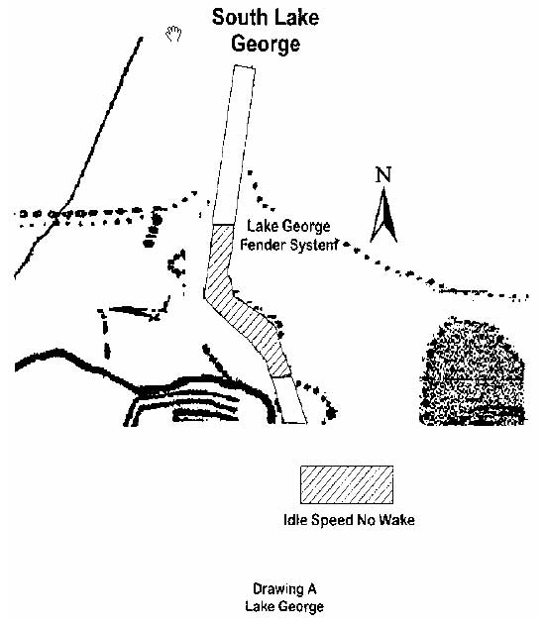

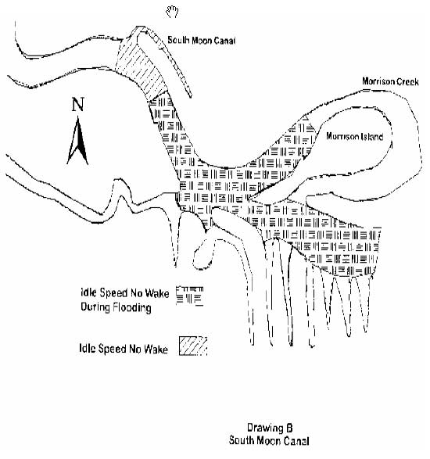

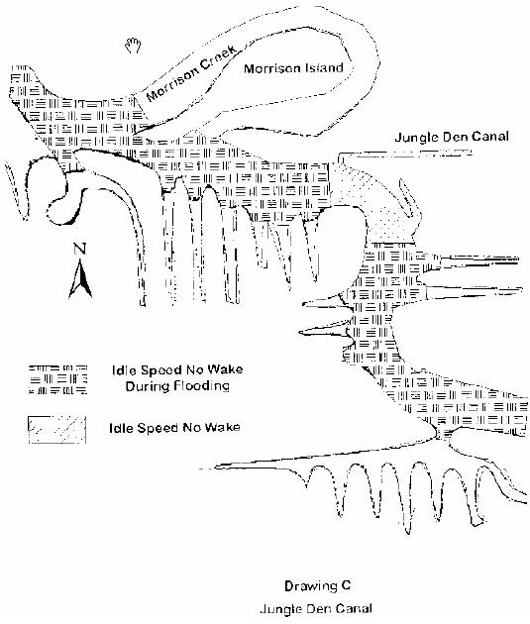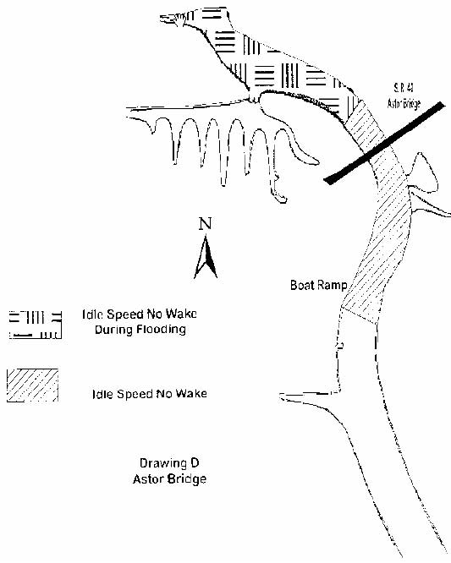

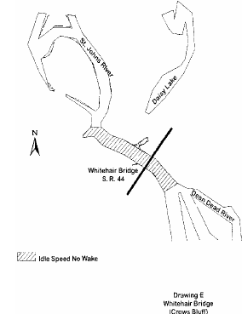

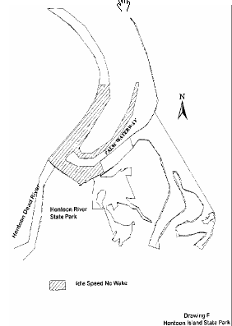

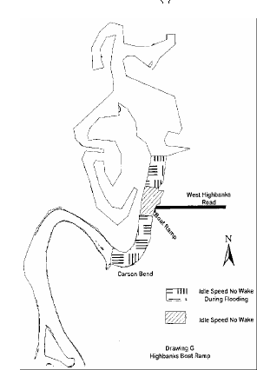
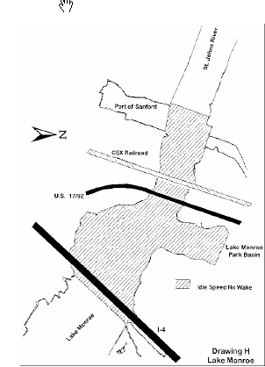
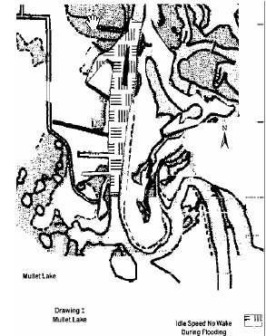

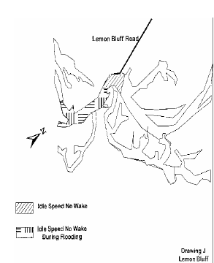

Rulemaking Authority 327.04, 327.46 FS. Law Implemented 327.33(3), 327.46 FS. History–New 6-3-92, Formerly 16N-24.018, Amended 10-3-95, 11-21-96, 2-4-98, Formerly 62N-24.018.

