68D-24.010 Pinellas County Boating Restricted Areas.
(1) For the purpose of regulating the speed and operation of vessel traffic on and adjacent to the Florida Intracoastal Waterway in Pinellas County, Florida, the following boating restricted areas are established:
(a) Slow Down Minimum Wake Zones
1. Pinellas Bayway Bridges – All waters lying south of the northern boundary of the right-of-way of the Florida Intracoastal Waterway between a line drawn perpendicular to the center line of the waterway 1,500 feet northwest of the Pinellas Bayway Bridge at Tierra Verde and a line drawn perpendicular to the center line of the waterway 500 feet southeast of said bridge including the waters adjacent to the Florida Intracoastal Waterway from the waterway south and west to the mean high water mark and all waters lying within the right-of-way of the Florida Intracoastal Waterway between a line drawn perpendicular to the center line of the waterway 500 feet north of span “C” of the Pinellas Bayway Bridge (State Road 682) and a line drawn perpendicular to the center line of the waterway 500 feet south of said bridge, as depicted in drawing A.
2. Corey Causeway to Treasure Island Causeway – All waters within the right-of-way of the Florida Intracoastal Waterway from a line drawn perpendicular to the center line of the waterway 800 feet east of the Corey Causeway Bridge to a line drawn perpendicular to the center line of the waterway 500 feet north of the Treasure Island Causeway Bridge, as depicted in drawing B.
3. Tom Stuart (Welch) Causeway – All waters lying north of the southern boundary of the right-of-way of the Florida Intracoastal Waterway between a line drawn perpendicular to the center line of the waterway 1,000 feet northwest of the Tom Stuart (Welch) Causeway at Madeira Beach and a line drawn perpendicular to the center line of the waterway 1,600 feet southeast of said bridge, including the waters adjacent to the Florida Intracoastal Waterway from the waterway north and east to the mean high water mark, as depicted in drawing C.
4. Park Boulevard Bridge – All waters in and adjacent to the Florida Intracoastal Waterway, from shoreline to shoreline, from a line drawn perpendicular to the center line of the waterway 2,950 feet north of the Park Boulevard Bridge to a line drawn perpendicular to the center line of the waterway 5,766 feet south of said bridge, as depicted in drawing D.
5. Indian Rocks Bridge – All waters in and adjacent to the Florida Intracoastal Waterway, from shoreline to shoreline, from a line drawn perpendicular to the center line of the waterway 1,850 feet northeast of the Indian Rocks Bridge to a line drawn perpendicular to the center line of the waterway 6,928 feet south of said bridge, as depicted on drawing E.
6. Belleair Causeway – All waters lying within the right-of-way of the Florida Intracoastal Waterway between a line drawn perpendicular to the center line of the waterway 500 feet northeast of the Belleair Causeway and a line drawn perpendicular to the center line of the waterway 500 feet southwest of said bridge, as depicted in drawing F.
7. Memorial Causeway, S.R. 60 – A Slow Speed Minimum Wake zone from the centerline of S.R. 60, to 500 feet southwest of S.R. 60 to 3,180 feet northeast of the centerline of S.R. 60 to include all waters from the western right-of-way of the Florida Intracoastal Waterway to the shoreline of the City of Clearwater, as depicted in drawing G.
8. Honeymoon Island Causeway, State Road 586 – All waters lying within the right-of-way of the Intracoastal Waterway between a line drawn perpendicular to the center line of the waterway 500 feet north of the Honeymoon Island Causeway at Dunedin and a line drawn perpendicular to the center line of the waterway 500 feet southwest of said bridge, as depicted in drawing H.
(b) Thirty miles per hour zone –
1. Except as provided in paragraph (a) above, all waters lying within the right-of-way of the Intracoastal Waterway between the Pinellas Bayway Bridge at Tierra Verde and the Honeymoon Island Causeway are designated as a 30 miles per hour maximum speed zone. For the purposes of enforcement of this subparagraph, law enforcement officers may use aircraft, vessels, manual or electronic timing devices, or radar. If radar is used, the provisions of Section 316.1906, F.S., shall be complied with.
2. This paragraph shall not be interpreted to mean that 30 miles per hour is a safe speed for all vessels under all circumstances. Inland Navigation Rule 6, as adopted pursuant to Section 327.33(3), F.S., requires that every vessel shall at all times be operated at a safe speed. Compliance with Inland Navigation Rule 6 may require speeds well under 30 miles per hour.
(2) Pinellas County and the City of Clearwater are authorized to install and maintain appropriate regulatory markers as directed by the Division of Law Enforcement within the boating restricted areas and shall install and maintain the “Slow Speed Minimum Wake” and “Resume Normal Safe Operation” markers at the northern and southern boundaries of the boating restricted areas.
(3) The boating restricted areas are depicted in the following drawings:

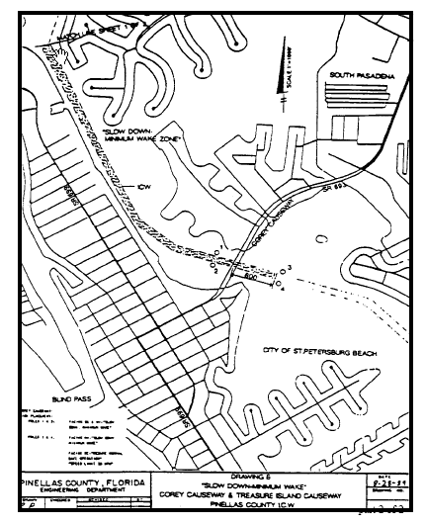

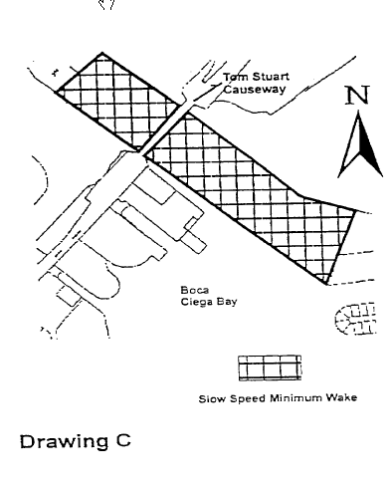

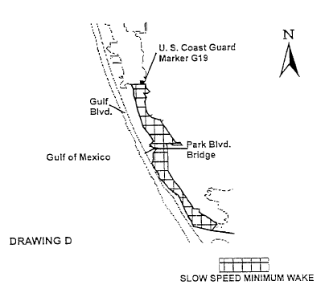
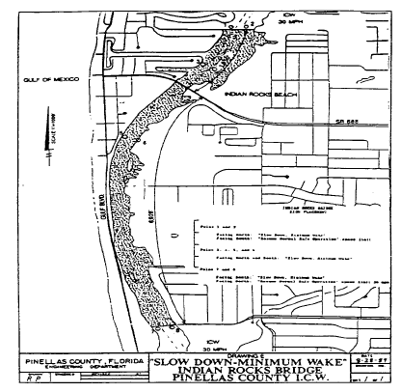

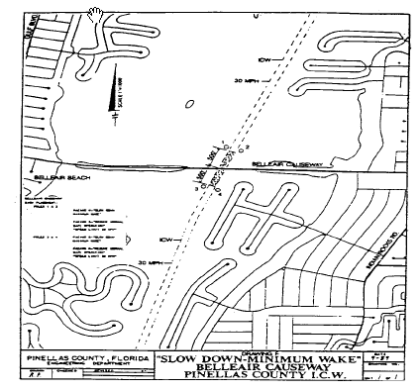

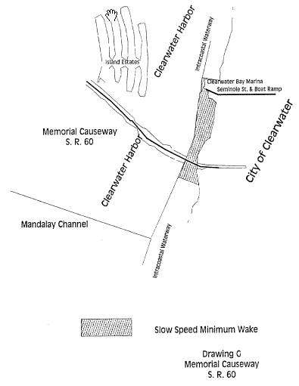

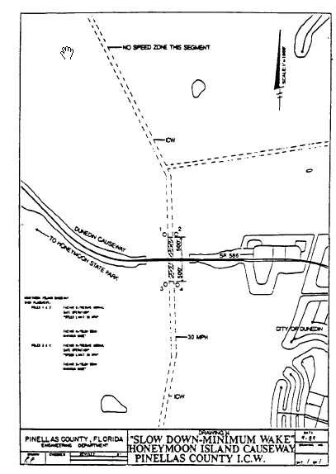

Rulemaking Authority 327.46 FS. Law Implemented 327.46 FS. History–New 9-18-88, Amended 12-7-89, Formerly 16N-24.010, Amended 10-1-96, Formerly 62N-24.010, Amended 10-2-00.

