68D-24.155 St. Johns County Boating Restricted Areas.
(1) The following slow speed minimum wake year-round zones are established regulating the speed and operation of vessel traffic on and adjacent to the Florida Intracoastal Waterway within St. Johns County. The zones exclude all associated tributaries, creeks, canals, channels, backwaters, boat basins and other waterways unless otherwise designated or specifically described for inclusion:
(a) Palm Valley Bridge (S.R. 210) – All waters in and adjacent to the Florida Intracoastal Waterway, from shoreline to shoreline, from a line drawn perpendicular to the centerline of the Florida Intracoastal Waterway 500 feet northwest of the Palm Valley Bridge (S.R. 210), to a line drawn perpendicular to the centerline of the Florida Intracoastal Waterway 500 feet southeast of said bridge, as depicted in Drawing A.
(b) Vilano Beach Bridge (A1A) – All waters in and adjacent to the Florida Intracoastal Waterway, from shoreline to shoreline, from a line drawn perpendicular to the centerline of the Florida Intracoastal Waterway 500 feet north of the Vilano Beach Bridge (A1A), to a point on the western shoreline (29° 54.935 N/81° 17.898 W) 200 feet south of the bridge, to a point on the eastern shoreline (29° 54.964 N/81° 18.318 W) 900' feet south of said bridge, as depicted in Drawing B.
(c) Bridge of Lions (A1A) – All waters in and adjacent to the Florida Intracoastal Waterway, from shoreline to shoreline, from a line drawn perpendicular to the centerline of the Florida Intracoastal Waterway 500' feet north of the Bridge of Lions (A1A), to a line drawn perpendicular to the centerline of the Florida Intracoastal Waterway 775' feet southeast of said bridge, as depicted in Drawing C.
(d) S.R. 312 Bridge – All waters in and adjacent to the Florida Intracoastal Waterway, from shoreline to shoreline, from a line drawn perpendicular to the centerline of the Florida Intracoastal Waterway 500' feet north of the S.R. 312 Bridge, to a line drawn perpendicular to the centerline of the Florida Intracoastal Waterway 500' feet south of said bridge, as depicted in Drawing D.
(e) Crescent Beach Bridge (S.R. 206) – All waters in and adjacent to the Florida Intracoastal Waterway, from shoreline to shoreline, from a line drawn perpendicular to the centerline of the Florida Intracoastal Waterway 500' feet northwest of the Crescent Beach Bridge (S.R. 206), to a line drawn perpendicular to the centerline of the Florida Intracoastal Waterway 500' feet southeast of said bridge, as depicted in Drawing E.
(f) Devil’s Elbow Boat Ramp – All waters in and adjacent to the Florida Intracoastal Waterway, from a line drawn perpendicular to the centerline of the Florida Intracoastal Waterway 500 feet northeast of the Devil’s Elbow Boat Ramp, to a line drawn perpendicular to the centerline of the Florida Intracoastal Waterway 500 feet south of said boat ramp, bounded on the west by a line drawn from point (29° 45.112 N/81° 15.071 W) to point (29° 45.263 N/81° 15.092 W), and bounded on the east by the shoreline, as depicted in Drawing F.
(2) The boating restricted areas are depicted on the following drawings:
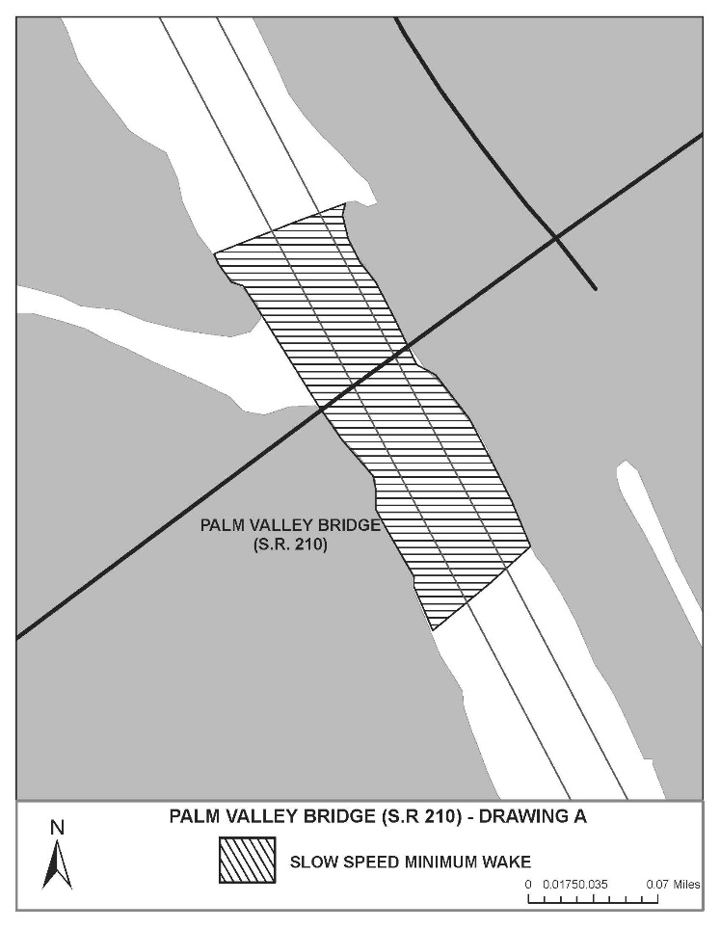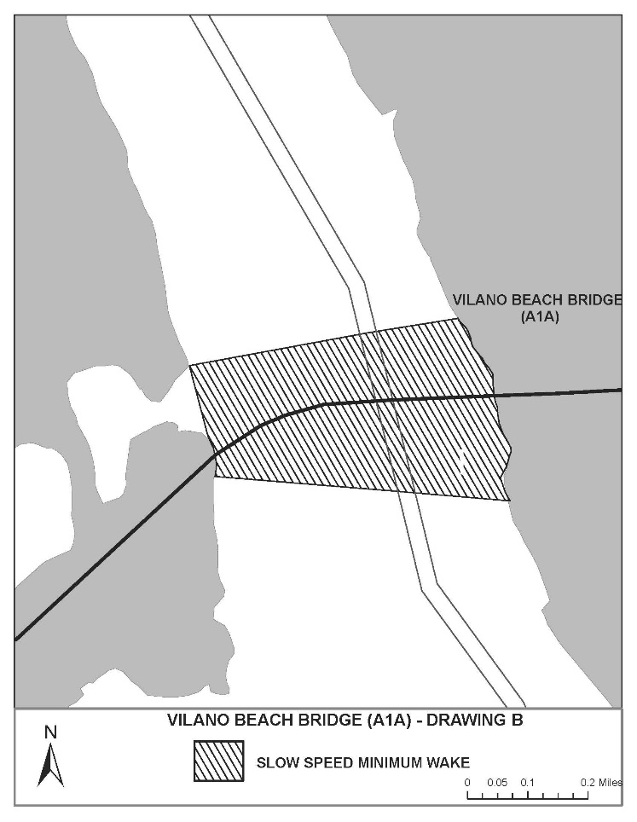
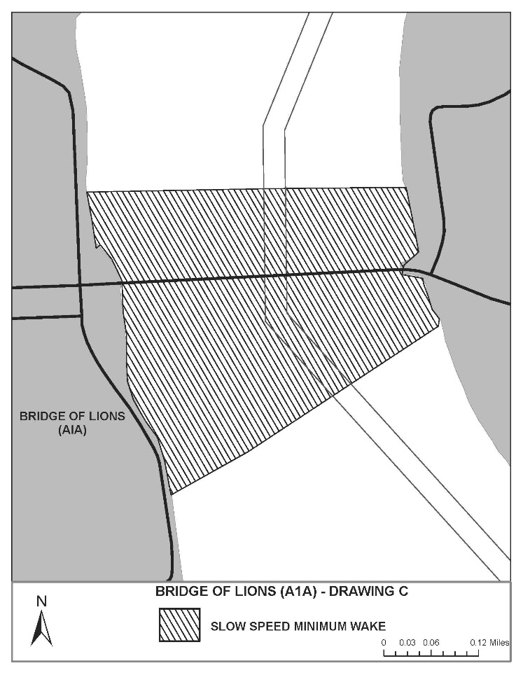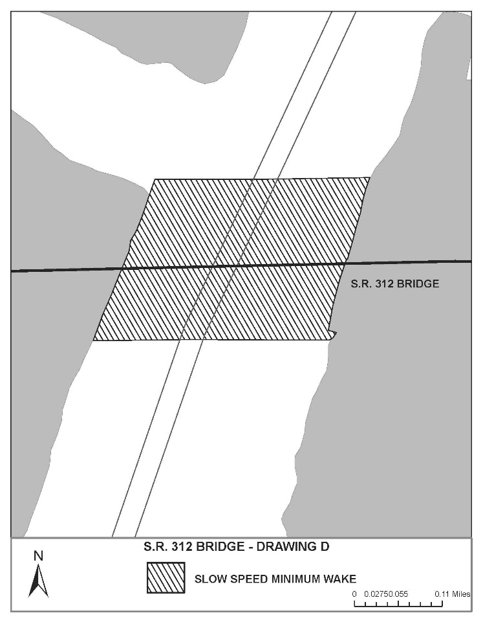
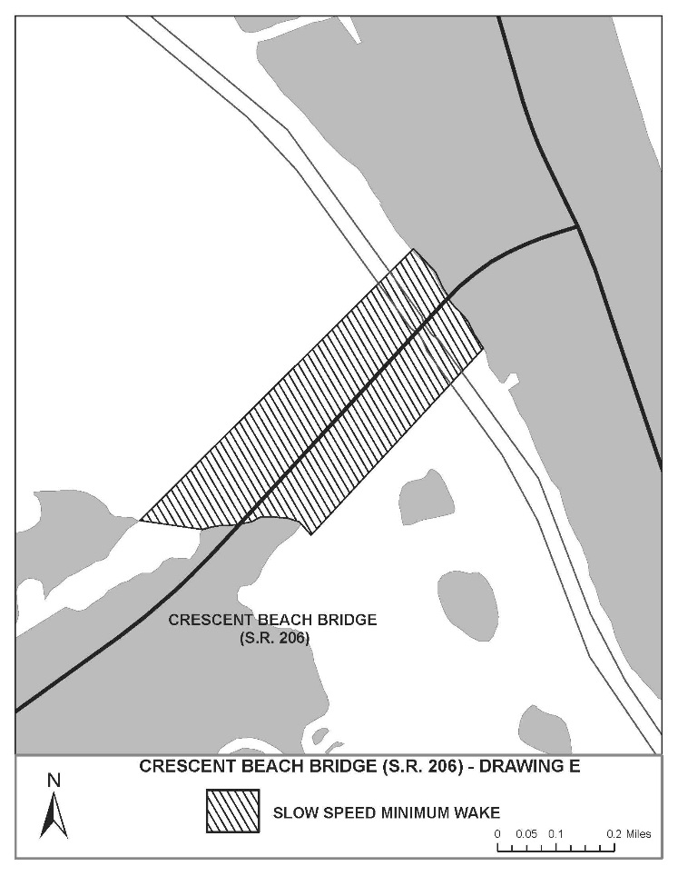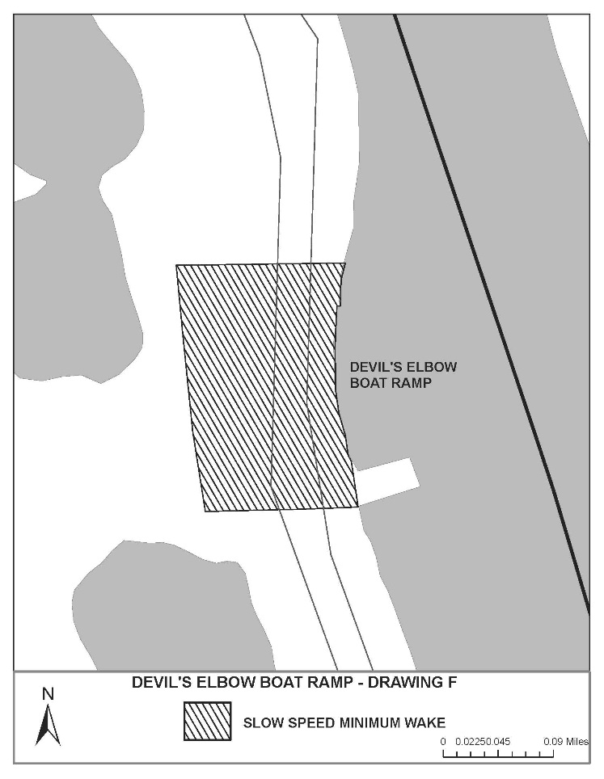
Rulemaking Authority 327.04, 327.46 FS. Law Implemented 327.46 FS. History–New 12-11-97, Formerly 62N-24.155, Amended 11-14-01, 5-23-11, 5-11-15.

