69A-3.012 Standards of the National Fire Protection Association and Other Standards Adopted.
(1) Except as specifically modified by statute or by the State Fire Marshal’s rules, the Florida specific edition of NFPA 101, the Life Safety Code®, 2009 edition and the Florida specific edition of NFPA 1, the Fire Code 2009 edition, as adopted within Rule Chapter 69A-60, F.A.C., entitled the “2010 edition of the Florida Fire Prevention Code,” are hereby adopted and incorporated by reference and are applicable to those buildings and structures specified in paragraphs (a) and (b) of subsection (1) of Section 633.206, F.S. In addition, the following standards, except as specifically modified in the rule chapters in Rule Title 69A, are hereby adopted and incorporated by reference and shall take effect on the effective date of this rule, as a part of the uniform fire safety standards adopted by rule by the State Fire Marshal and are applicable to those buildings and structures specified in paragraphs (a) and (b) of subsection (1) of Section 633.206, F.S.:
NFPA 10-2007 edition, Standard for Portable Fire Extinguishers
NFPA 11-2005 edition, Standard for Low-, Medium-, and High- Expansion Foam
NFPA 12-2008 edition, Standard on Carbon Dioxide Extinguishing Systems
NFPA 12A-2009 edition, Standard on Halon 1301 Fire Extinguishing Systems
NFPA 13-2007 edition, Standard for the Installation of Sprinkler Systems
NFPA 13D-2007 edition, Standard for the Installation of Sprinkler Systems in One- and Two- Family Dwellings and Manufactured Homes
NFPA 13R-2007 edition, Standard for the Installation of Sprinkler Systems in Residential Occupancies up to and including Four Stories in Height
NFPA 14-2007 edition, Standard for the Installation of Standpipe and Hose Systems
NFPA 15-2007 edition, Standard for Water Spray Fixed Systems for Fire Protection
NFPA 16-2007 edition, Standard for the Installation of Foam-Water Sprinkler and Foam-Water Spray Systems
NFPA 17-2009 edition, Standard for Dry Chemical Extinguishing Systems
NFPA 17A-2009 edition, Standard on Wet Chemical Extinguishing Systems
NFPA 20-2007 edition, Standard for the Installation of Stationary Pumps for Fire Protection
NFPA 22-2008 edition, Standard for Water Tanks for Private Fire Protection
NFPA 24-2007 edition, Standards for the Installation of Private Fire Service Mains and Their Appurtenances
NFPA 25-2008 edition, Standard for the Inspection, Testing, and Maintenance of Water-Based Fire Protection Systems
NFPA 30-2008 edition, Flammable and Combustible Liquids Code
NFPA 30A-2008 edition, Code for Motor Fuel Dispensing Facilities and Repair Garages
NFPA 30B-2007 edition, Code for the Manufacture and Storage of Aerosol Products
NFPA 31-2006 edition, Standard for the Installation of Oil Burning Equipment
NFPA 32-2007 edition, Standards for Drycleaning Plants
NFPA 33-2007 edition, Standard for Spray Application Using Flammable or Combustible Materials
NFPA 34-2007 edition, Standard for Dipping and Coating Processes Using Flammable or Combustible Liquids
NFPA 35-2005 edition, Standard for the Manufacture of Organic Coatings
NFPA 36-2004 edition, Standard for Solvent Extraction Plants
NFPA 37-2006 edition, Standard for the Installation and Use of Stationary Combustion Engines and Gas Turbines
NFPA 40-2007 edition, Standard for the Storage and Handling of Cellulose Nitrate Film
NFPA 45-2004 edition, Standard on Fire Protection for Laboratories Using Chemicals
NFPA 51-2007 edition, Standard for the Design and Installation of Oxygen-Fuel Gas Systems for Welding, Cutting and Allied Processes
NFPA 51A-2006 edition, Standard for Acetylene Cylinder Charging Plants
NFPA 51B-2009 edition, Standard for Fire Prevention During Welding, Cutting and Other Hot Work
NFPA 52-2006 edition, Vehicular Fuel Systems Code
NFPA 53-2011 edition, Recommended Practice on Materials, Equipment, and Systems Used in Oxygen-Enriched Atmospheres
NFPA 54-2009 edition, National Fuel Gas Code
NFPA 55-2005 edition, Standard for the Storage, Use, and Handling of Compressed Gasses and Cryogenic Fluids in Portable and Stationary Containers, Cylinders and Tanks
NFPA 58-2008 edition, Liquefied Petroleum Gas Code
NFPA 59-2008 edition, Utility LP-Gas Plant Code
NFPA 59A-2009 edition, Standard for the Production, Storage and Handling of Liquefied Natural Gas (LNG)
NFPA 61-2008 edition, Standard for the Prevention of Fires and Dust Explosions in Agricultural and Food Products Facilities
NFPA 68-2007 edition, Standard on Explosion Protection by Deflagration Venting
NFPA 69-2008 edition, Standard on Explosion Prevention Systems
NFPA 70-2008 edition, National Electrical Code®
NFPA 72-2007 edition, National Fire Alarm Code®
NFPA 75-2009 edition, Standard for the Protection of information Technology Equipment
NFPA 80-2007 edition, Standard for Fire Doors and Other Opening Protectives
NFPA 80A-2007 edition, Recommended Practice for Protection of Buildings from Exterior Fire Exposures
NFPA 82-2004 edition, Standard on Incinerators and Waste and Linen Handling Systems and Equipment
NFPA 85-2007 edition, Boiler and Combustion Systems Hazards Code
NFPA 86-2007 edition, Standard for Ovens and Furnaces
NFPA 88A-2007 edition, Standard for Parking Structures
NFPA 90A-2009 edition, Standard for the Installation of Air-Conditioning and Ventilating Systems
NFPA 90B-2009 edition, Standard for the Installation of Warm Air Heating and Air-Conditioning Systems
NFPA 91-2004 edition, Standard for Exhaust Systems for Air Conveying of Vapors, Gases, Mists, and Noncombustible Particulate Solids
NFPA 92A-2009 edition, Standard for Smoke-Control Systems Utilizing Barriers and Pressure Differences
NFPA 92B-2009 edition, Standard for Smoke Management Systems in Malls, Atria, and Large Spaces
NFPA 96-2008 edition, Standard for Ventilation Control and Fire Protection of Commercial Cooking Operations. Section 10-2.3 of NFPA 96 applies prospectively only. Existing installations are permitted to remain in place subject to the approval of the authority having jurisdiction.
NFPA 99-2005 edition, Standard for Health Care Facilities
NFPA 99B-2010 edition, Standard for Hypobaric Facilities
NFPA 101A-2007 edition, Guide on Alternative Approaches to Life Safety
NFPA 102-2006 edition, Standard for Grandstands, Folding and Telescoping Seating, Tents and Membrane Structures
NFPA 105-2007 edition, Standard for the Installation of Smoke Door Assemblies and Other Opening Protectives
NFPA 110-2005 edition, Standard for Emergency and Standby Power Systems
NFPA 111-2005 edition, Standard on Stored Electrical Energy Emergency and Standby Power Systems
NFPA 115-2008 edition, Standard for Laser Fire Protection
NFPA 120-2004 edition, Standard for Fire Prevention and Control in Coal Mines
NFPA 122-2004 edition, Standard for Fire Prevention and Control in Metal/Nonmetal Mining and Metal Mineral Processing Facilities
NFPA 130-2010 edition, Standard for Fixed Guideway Transit and Passenger Rail Systems
NFPA 140-2008 edition, Standard on Motion Picture and Television Production Studio Soundstages, Approved Production Facilities, and Production Locations
NFPA 150-2007 edition, Standard on Fire and Life Safety in Animal Housing Facilities
NFPA 160-2006 edition, Standard for Use of Flame Effects Before an Audience
NFPA 170-2006 edition, Standard for Fire Safety and Emergency Symbols
NFPA 204-2007 edition, Standard for Smoke and Heat Venting
NFPA 211-2006 edition, Standard for Chimneys, Fireplaces, Vents, and Solid Fuel Burning Appliances
NFPA 214-2011 edition, Standard on Water-Cooling Towers
NFPA 221-2009 edition, Standard for High Challenge Fire Walls, Fire Walls, and Fire Barrier Walls
NFPA 232-2007 edition, Standard for the Protection of Records
NFPA 241-2004 edition, Standard for Safeguarding Construction, Alteration and Demolition Operations
NFPA 251-2006 edition, Standard Methods of Tests of Fire Resistance of Building Construction and Materials
NFPA 252-2008 edition, Standard Methods of Fire Tests of Door Assemblies
NFPA 253-2006 edition, Standard Method of Test for Critical Radiant Flux of Floor Covering Systems Using a Radiant Heat Energy Source
NFPA 255-2006 edition, Standard Method of Test of Surface Burning Characteristics of Building Materials
NFPA 256-2003 edition, Standard Methods of Fire Tests of Roof Coverings
NFPA 257-2007 edition, Standard on Fire Tests for Window and Glass Block Assemblies
NFPA 259-2008 edition, Standard Test Method for Potential Heat of Building Materials
NFPA 260-2009 edition, Standard Methods of Test and Classification System for Cigarette Ignition Resistance of Components of Upholstered Furniture
NFPA 261-2009 edition, Standard Method of Test for Determining Resistance of Mock-Up Upholstered Furniture Material Assemblies to Ignition by Smoldering Cigarettes
NFPA 265-2007 edition, Standard Methods of Fire Tests for Evaluating Room Fire Growth Contribution of Textile Coverings on full Height Panels and Walls
NFPA 271-2004 edition, Standard Method of Test for Heat and Visible Smoke Release Rates for Materials and Products Using an Oxygen Consumption Calorimeter
NFPA 286-2006 edition, Standard Methods of Fire Test for Evaluating Contribution of Wall and Ceiling Interior Finish to Room Fire Growth
NFPA 288-2007 edition, Standard Methods of Fire Tests of Floor Fire Door Assemblies Installed Herizontally in Fire Resistance-Rated Floor Systems
NFPA 291-2007 edition, Recommended Practice for Fire Flow Testing and Marking of Hydrants
NFPA 302-2004 edition, Fire Protection Standard for Pleasure and Commercial Motor Craft
NFPA 303-2006 edition, Fire Protection Standards for Marinas and Boatyards
NFPA 307-2006 edition, Standard for the Construction and Fire Protection of Marine Terminals, Piers, and Wharves
NFPA 312-2006 edition, Standard for Fire Protection of Vessels During Construction, Conversion, Repair, and Lay-Up
NFPA 318-2009 edition, Standard for the Protection of Semiconductor Fabrication Facilities
NFPA 326-2005 edition, Standard for the Safeguarding of Tanks and Containers for Entry, Cleaning, or Repair
NFPA 385-2007 edition, Standard for Tank Vehicles for Flammable and Combustible Liquids
NFPA 407-2007 edition, Standard for Aircraft Fuel Servicing
NFPA 409-2004 edition, Standard on Aircraft Hangars
NFPA 410-2004 edition, Standard on Aircraft Maintenance
NFPA 415-2008 edition, Standard on Airport Terminal Buildings, Fueling Ramp Drainage, and Loading Walkways
NFPA 418-2006 edition, Standard for Heliports
NFPA 430-2004 edition, Code for Storage of Liquid and Solid Oxidizers
NFPA 432-2002 edition, Code for Storage of Organic Peroxide Formulations
NFPA 434-2002 edition, Code for the Storage of Pesticides
NFPA 484-2009 edition, Standard for Combustible Metals
NFPA 490-2002 edition, Code for the Storage of Ammonium Nitrate
NFPA 495-2006 edition, Explosive Materials Code
NFPA 498-2006 edition, Standard for Safe Havens and Interchange Lots for Vehicles Transporting Explosives
NFPA 501-2005 edition, Standard on Manufactured Housing
NFPA 501A-2005 edition, Standard for Firesafety Criteria for Manufactured Home Installations, Sites, and Communities
NFPA 502-2011 edition, Standard for Road Tunnels, Bridges, and Other Limited Access Highways
NFPA 505-2006 edition, Fire Safety Standard for Powered Industrial Trucks Including Type Designations, Areas of Use, Conversions, Maintenance, and Operation
NFPA 560-2007 edition, Standard for the Storage, Handling, and Use of Ethylene Oxide for Sterilization and Fumigation
NFPA 601-2005 edition, Standard for Security Services in Fire Loss Prevention
NFPA 654-2006 edition, Standard for the Prevention of Fire and Dust Explosions from the Manufacturing, Processing, and Handling of Combustible Particulate Solids
NFPA 655-2007 edition, Standard for Prevention of Sulfur Fires and Explosions
NFPA 664-2007 edition, Standard for the Prevention of Fires and Explosions in Wood Processing and Woodworking Facilities
NFPA 701-2004 edition, Standard Methods of Fire Tests for Flame Propagation of Textiles and Films
NFPA 703-2009 edition, Standard for Fire Retardant-Treated Wood and Fire-Retardant Coatings for Building Materials
NFPA 704-2007 edition, Standard System for the Identification of the Hazards of Materials for Emergency Response
NFPA 750-2006 edition, Standard on Water Mist Fire Protection Systems
NFPA 780-2011 edition, Standard for the Installation of Lightning Protection Systems
NFPA 820-2008 edition, Standard for Fire Protection in Wastewater Treatment and Collection Facilities
NFPA 850-2010 edition, Recommended Practice for Fire Protection for Electric Generating Plants and High Voltage Direct Current Converter Stations
NFPA 909-2005 edition, Code for the Protection of Cultural Resources Properties – Museums, Libraries, and Places of Worship
NFPA 914-2007 edition, Code for Fire Protection of Historic Structures
NFPA 1122-2008 edition, Code for Model Rocketry
NFPA 1123-2006 edition, Code for Fireworks Display
NFPA 1124-2006 edition, Code for the Manufacture, Transportation, Storage, and Retail Sale of Fireworks and Pyrotechnic Articles
NFPA 1125-2007 edition, Code for the Manufacture of Model Rocket and High Power Rocket Motors
NFPA 1126-2006 edition, Standard for the Use of Pyrotechnics Before a Proximate Audience
NFPA 1127-2008 edition, Code for High Power Rocketry
NFPA 1142-2007 edition, Standard on Water Supplies for Suburban and Rural Fire Fighting
NFPA 1144-2008 edition, Standard for Reducing Structure Ignition Hazards from Wildland Fire
NFPA 1192-2008 edition, Standard on Recreational Vehicles
NFPA 1194-2008 edition, Standard for Recreational Vehicle Parks and Campgrounds
NFPA 1221-2010 edition, Standard for the Installation, Maintenance, and Use of Emergency Services Communications Systems
NFPA 1561-2008 edition, Standard on Emergency Services Incident Management System
NFPA 1600-2007 edition, Standard on Disaster/Emergency Management and Business Continuity Programs
NFPA 1962-2008 edition, Standard for the Inspection, Care, and Use of Fire Hose, Couplings, and Nozzles and the Service Testing of Fire Hose
NFPA 1963-2003 edition, Standards for Fire Hose Connections
NFPA 2001-2008 edition, Standard on Clean Agent Fire Extinguishing Systems
The portions of 49 Code of Federal Regulations, Parts 100-177 which are referenced in Compressed Gas Association CGA C-1-1996, Methods for Hydrostatic Testing of Compressed Gas Cylinders, Compressed Gas Association CGA C-6-1993, Standards for Visual Inspection of Steel Compressed Gas Cylinders, Seventh Edition, Reaffirmed 1995, Compressed Gas Association CGA C-6.1-1995, Standards for Visual Inspection of High Pressure Aluminum Compressed Gas Cylinders, and Compressed Gas Association CGA C-6.3-1999 Guidelines for Visual Inspection and Requalification of Low Pressure Aluminum Compressed Gas Cylinders, Second Edition, and which pertain to low pressure and high pressure cylinders.
The portions of 29 Code of Federal Regulations, Parts 1900-1910 which are referenced in Compressed Gas Association CGA C-1-1996, Methods for Hydrostatic Testing of Compressed Gas Cylinders, Compressed Gas Association CGA C-6-1993, Standards for Visual Inspection of Steel Compressed Gas Cylinders, Seventh Edition, Reaffirmed 1995, Compressed Gas Association CGA C-6.1-1995, Standards for Visual Inspection of High Pressure Aluminum Compressed Gas Cylinders, and Compressed Gas Association CGA C-6.3-1999 Guidelines for Visual Inspection and Requalification of Low Pressure Aluminum Compressed Gas Cylinders, Second Edition, and which pertain to low pressure and high pressure cylinders.
Compressed Gas Association CGA C-1-1996, Methods for Hydrostatic Testing of Compressed Gas Cylinders.
Compressed Gas Association CGA C-6-1993, Standards for Visual Inspection of Steel Compressed Gas Cylinders, Seventh Edition, Reaffirmed 1995.
Compressed Gas Association CGA C-6.1-1995, Standards for Visual Inspection of High Pressure Aluminum Compressed Gas Cylinders.
Compressed Gas Association CGA C-6.3-1999, Guidelines for Visual Inspection and Requalification of Low Pressure Aluminum Compressed Gas Cylinders, Second Edition.
(2) All buildings, structures, establishments, facilities, equipment, or vehicular equipment over which the State Fire Marshal has jurisdiction which are constructed, renovated, expanded, rehabilitated, or in any other way significantly altered on or after the effective date of the adoption of the codes and standards adopted in subsection (1), above, shall conform to the requirements of the codes, standards, recommended practices, and manuals contained therein, unless the structure, establishment, or facility has been exempted from complying because the building, structure, establishment, facility, equipment, or vehicular equipment has been granted an exemption from compliance by act of the Legislature.
(3) All buildings, structures, establishments, facilities, equipment, or vehicular equipment over which the State Fire Marshal has jurisdiction which are in existence on or after the effective date of the adoption of the codes and standards adopted in subsection (1), above, shall conform to the requirements of those codes and standards within a reasonable period of time. It is understood that the correction of some fire safety violations will necessitate the employment of design professionals while other violations can be expeditiously resolved. “Within a reasonable time” is defined as the amount of time it would normally take to correct a specific fire code violation under the assumption that the property owner would begin to correct said violations upon receipt of an official document from the enforcing agency.
(4) The codes and standards published by the National Fire Protection Association, including the Florida edition of NFPA 1 and NFPA 101 as adopted in Rule Chapter 69A-60, F.A.C., may be obtained by writing to BNi, 990 Park Center Dr., Suite E, Vista, CA 92081-8352. ANSI standards may be obtained from the American National Standards Institute, 25 West 43rd Street, 4th Floor, New York, N.Y. 10036. ANSI/ASME standards may be obtained from the American Society of Mechanical Engineers, Two Park Avenue, New York, N.Y. 10016-5990. ASTM standards may be obtained from the American Society for Testing and Materials, 100 Barr Harbor Drive, West Conshohocken, PA 19428-2959. UL standards may be obtained from Underwriters Laboratories, Inc., 333 Pfingston Road, Northbrook, IL 60062. All standards incorporated by reference in this rule are also available for public inspection during regular business hours at the Division currently located on the third floor (Room 326) of the Atrium Building, 325 John Knox Road, Tallahassee, Florida.
(5) The Code of Federal Regulations and the Compressed Gas Association (CGA) documents incorporated by reference in this rule are available for public inspection during regular business hours at the Division currently located on the third floor (Room 326) of the Atrium Building, 325 John Knox Road, Tallahassee, Florida.
(6) Notice required for structures with light-frame truss-type construction.
Purpose: The purpose of this rule is to require the placement of an identifying symbol on structures constructed with a light-frame truss component in a manner sufficient to warn persons conducting fire control and other emergency operations of the existence of light-frame truss-type construction in the structure.
(a) Definitions.
1. “Light-frame truss-type construction” means a type of construction whose primary structural elements are formed by a system of repetitive wood or light gauge steel framing members.
2. “Approved symbol” means a Maltese Cross measuring 8 inches horizontally and 8 inches vertically, of a bright red reflective color, designed in accordance with Figure 1.
(b) Any commercial, industrial, or any multiunit residential structure of three units or more which uses horizontal or vertical light-frame truss-type construction in any portion shall be marked with an approved symbol. Townhouses are not multiunit residential structures and therefore not subject to this rule. Each approved symbol shall include within the center circle one of the following designations:
1. Structures with light-frame truss roofs shall be marked with the letter “R”.
2. Structures with light-frame truss floor systems shall be marked with the letter “F”.
3. Structures with light-frame truss floor and roof systems shall be marked with the letters “R/F”.
(c) The approved symbol shall be placed within 24 inches to the left of the main entry door and:
1. Be permanently attached to the face of the structure on a contrasting background, or
2. Be mounted on a contrasting base material which is then permanently attached to the face of the structure.
(d) The distance above the grade, walking surface or the finished floor to the bottom of the symbol shall be not less than 4 feet (48 in).
(e) The distance above the grade, walking surface or the finished floor to the top of the symbol shall be not more than 6 feet (72 in).
(7) In single tenant structures with multiple main entry doors, such as big box retail stores, department stores and grocery stores, the authority having jurisdiction is authorized to require that other main entry doors of the structure be marked with an approved symbol to carry out the purpose in subsection (6) above.
(8) In multiple tenant structures and covered malls with multiple main entry doors, the authority having jurisdiction is authorized to require that other main entry doors be marked with an approved symbol to carry out the purpose in subsection (6) above. In such structures, approved symbols shall be marked on one side only and spaced not closer than 100 feet or at each end of the structure when such structure is less than 100 feet in length.
(9) The owner of each new structure required to comply with this section shall mark the structure with the approved symbol prior to receiving a certificate of occupancy.
(10) The owner of each existing structure required to comply with this section shall mark the structure with the approved symbol within 90 days of the effective date of this rule section.
(11) Where the owner of the structure and the authority having jurisdiction disagree as to the use of light-frame truss-type construction within the structure, the owner shall be granted not more than 45 days to provide written verification from a licensed engineer or licensed architect; otherwise the owner shall comply with the rule.
Figure 1:
Approved Symbol



Light-frame “Roof” only



Light- frame “Floor” only

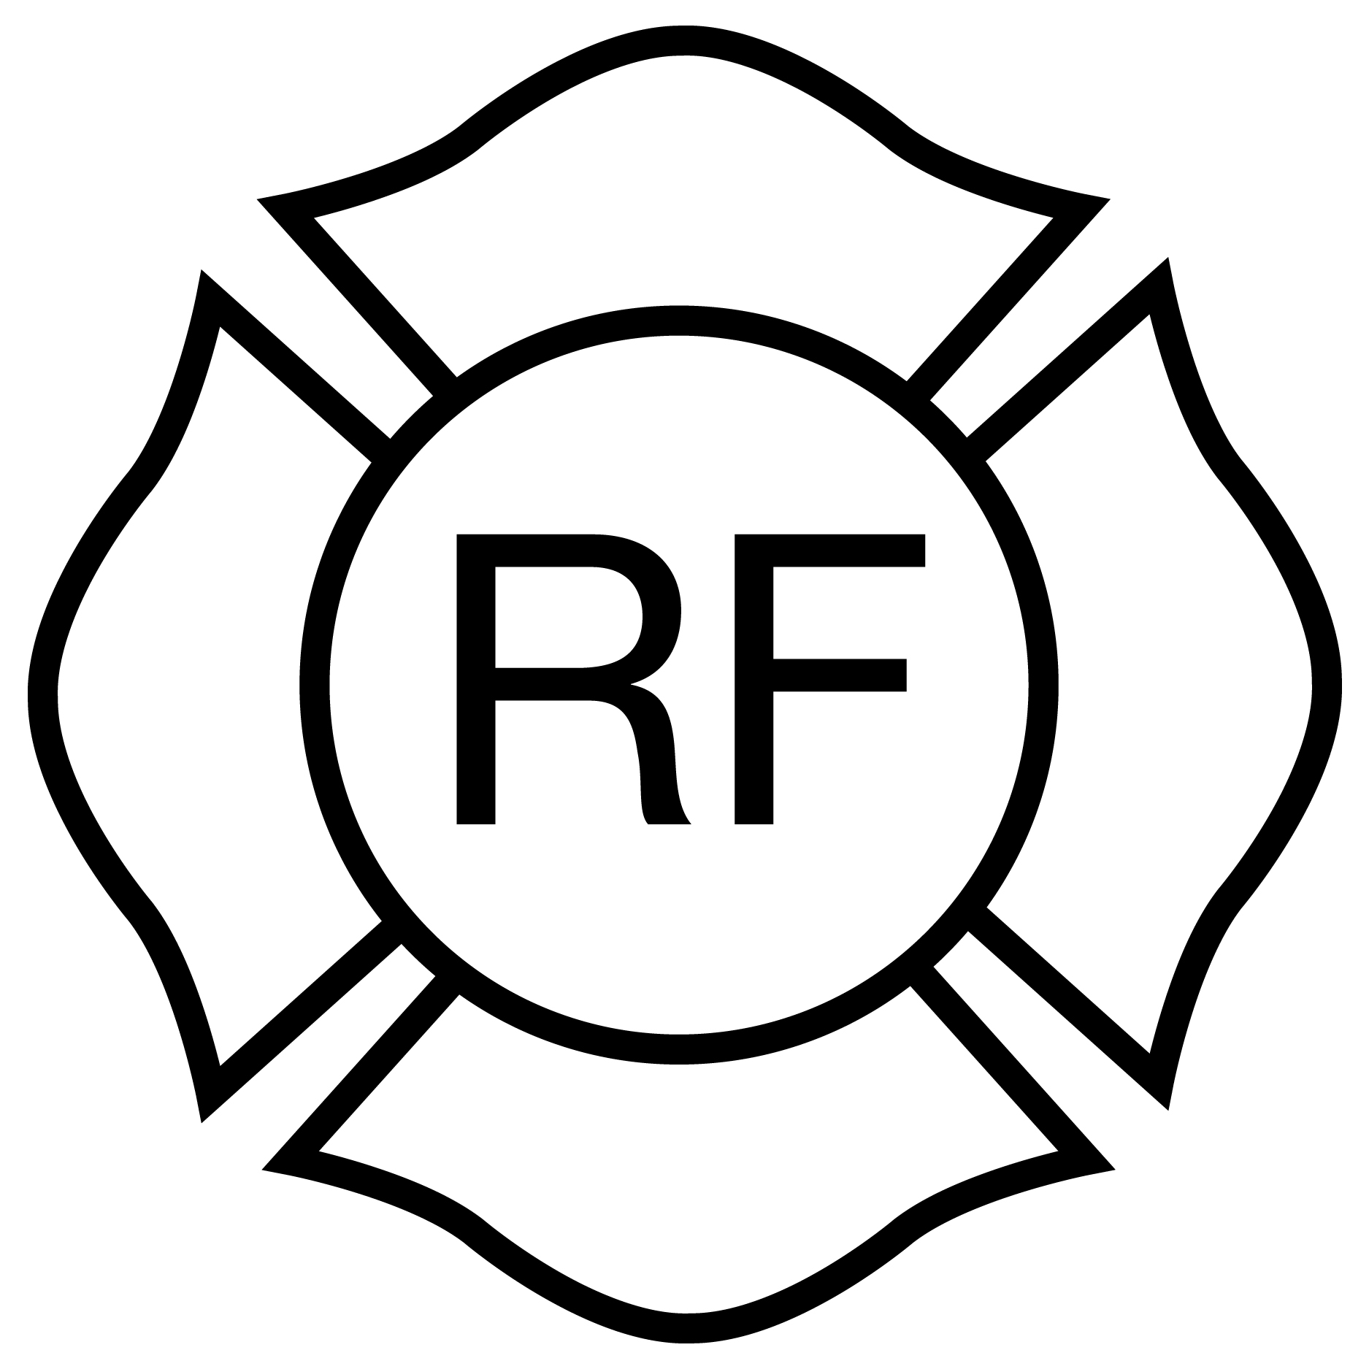

Light- frame “Floor & Roof”
Rulemaking Authority 633.104(1), 633.206, 633.202, 633.222 FS. Law Implemented 633.104(1), 633.202, 633.206, 633.222 FS. History–New 5-14-86, Amended 2-12-87, 4-8-90, 10-30-91, 4-3-95, 11-27-01, Formerly 4A-3.012, Amended 8-7-05, 5-18-08, 12-31-08, 12-13-09, 12-31-11.

