CHAPTER 62-342
MITIGATION BANKS
62-342.100 Intent
62-342.200 Definitions
62-342.300 Use of a Mitigation Bank (Repealed)
62-342.400 Criteria for Establishing a Mitigation Bank
62-342.450 Mitigation Bank Permit and Mitigation Bank Conceptual Approval Applications
62-342.470 Establishment of Mitigation Credits
62-342.600 Mitigation Service Area
62-342.650 Land Use Restrictions on Mitigation Banks
62-342.700 Financial Responsibility
62-342.750 Mitigation Bank Permit and Mitigation Bank Conceptual Approval
62-342.800 Surrender, Transfer, or Modification of Mitigation Bank Permits
62-342.850 Water Management District Mitigation Banks
62-342.900 Mitigation Banking Forms

62-342.100 Intent.
(1) The Department recognizes that, in certain instances, adverse impacts of activities regulated under Part IV of Chapter 373, F.S., can be offset through the utilization of mitigation credits from a permitted Mitigation Bank. This rule provides criteria for this mitigation alternative to complement existing mitigation criteria and requirements. This chapter is supplemental to and does not supersede any other criteria and requirements in rules promulgated under Part IV of Chapter 373, F.S.
(2) The Department intends that Mitigation Banks be used to minimize mitigation uncertainty associated with traditional mitigation practices and provide greater assurance of mitigation success. It is anticipated that the consolidation of multiple mitigation projects into larger contiguous areas will provide greater assurance that the mitigation will yield long-term, sustainable, regional ecological benefits. Mitigation Banks shall be consistent with Department endorsed watershed management objectives and emphasize restoration and enhancement of degraded ecosystems and the preservation of uplands and wetlands as intact ecosystems rather than alteration of landscapes to create wetlands. This is best accomplished through restoration of ecological communities that were historically present. The establishment and use of Mitigation Banks in or adjacent to areas of national, state, or regional ecological significance is encouraged, provided the area in which the Mitigation Bank is proposed to be located is determined appropriate for a Mitigation Bank and the Mitigation Bank meets all applicable permitting criteria.
(3) Nothing in this chapter shall affect the mitigation requirements set forth in any Mitigation Bank agreement or any permit issued under Chapter 84-79, Laws of Florida, or Part IV of Chapter 373, F.S., prior to February 2, 1994. If a permittee wishes to substantially modify a Mitigation Bank previously established by agreement or permit, the permittee must comply with this chapter. Additionally, some Mitigation Banks may be subject to the version of this section existing prior to July 1, 1996, under Sections 373.4136(9) and (10), F.S., and will not be affected by amendments adopted after that date. This chapter does not prohibit an applicant from proposing project-specific, pre-construction on-site or off-site mitigation, without establishing a Mitigation Bank.
Rulemaking Authority 373.4136(11) FS. Law Implemented 373.4135, 373.4136 FS. History–New 2-2-94, Formerly 17-342.100, Amended 5-21-01.

62-342.200 Definitions.
Terms used in this chapter shall have the meanings specified below.
(1) “Banker” means an entity that creates, operates, manages, or maintains a Mitigation Bank pursuant to a Mitigation Bank Permit.
(2) “Department” means the Department of Environmental Protection.
(3) “District” means a water management district as established in Chapter 373, F.S.
(4) “Ecological Value” means the value of functions performed by uplands, wetlands and other surface waters to the abundance, diversity, and habitats of fish, wildlife, and listed species. These functions include, but are not limited to: providing cover and refuge; breeding, nesting, denning, and nursery areas; corridors for wildlife movement; food chain support; and natural water storage, natural flow attenuation, and water quality improvement, which enhance fish, wildlife and listed species utilization.
(5) “Mitigation Credit” means a standard unit of measure which represents the increase in ecological value resulting from restoration, enhancement, preservation, or creation activities.
(6) “Mitigation Service Area” means the geographic area within which Mitigation Credits from a Mitigation Bank may be used to offset adverse impacts of activities regulated under Part IV of Chapter 373, F.S.
(7) “Mitigation Bank Permit” means a permit issued to a banker to construct, operate, manage and maintain a Mitigation Bank.
(8) “Mitigation Bank” means a project permitted under Section 373.4136, F.S., undertaken to provide for the withdrawal of mitigation credits to offset adverse impacts authorized by a permit under Part IV of Chapter 373, F.S.
(9) “Regional Watershed” means a watershed as delineated in the following maps. (Figures 1, 2, 3, 4, and 5.)
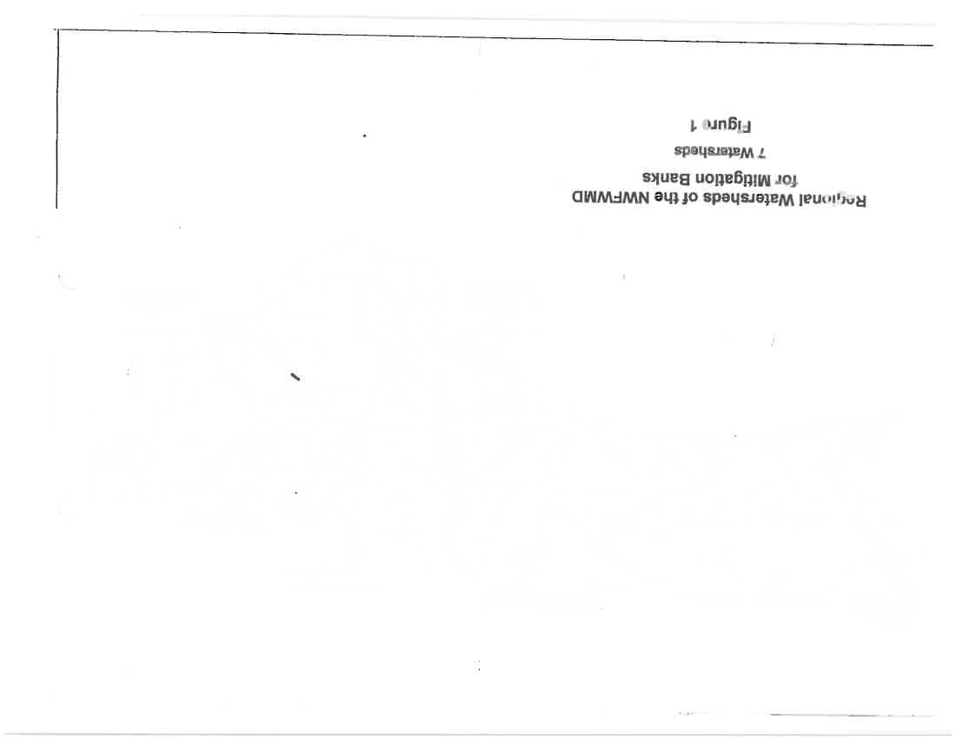

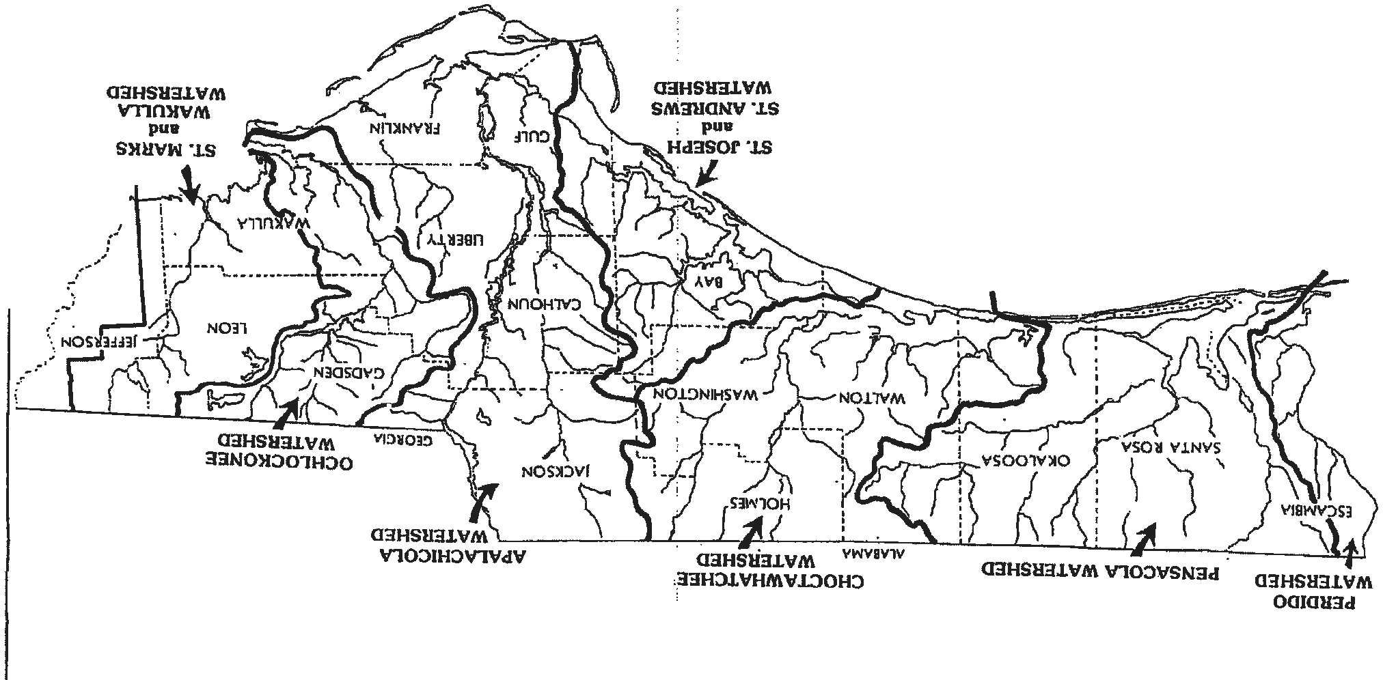



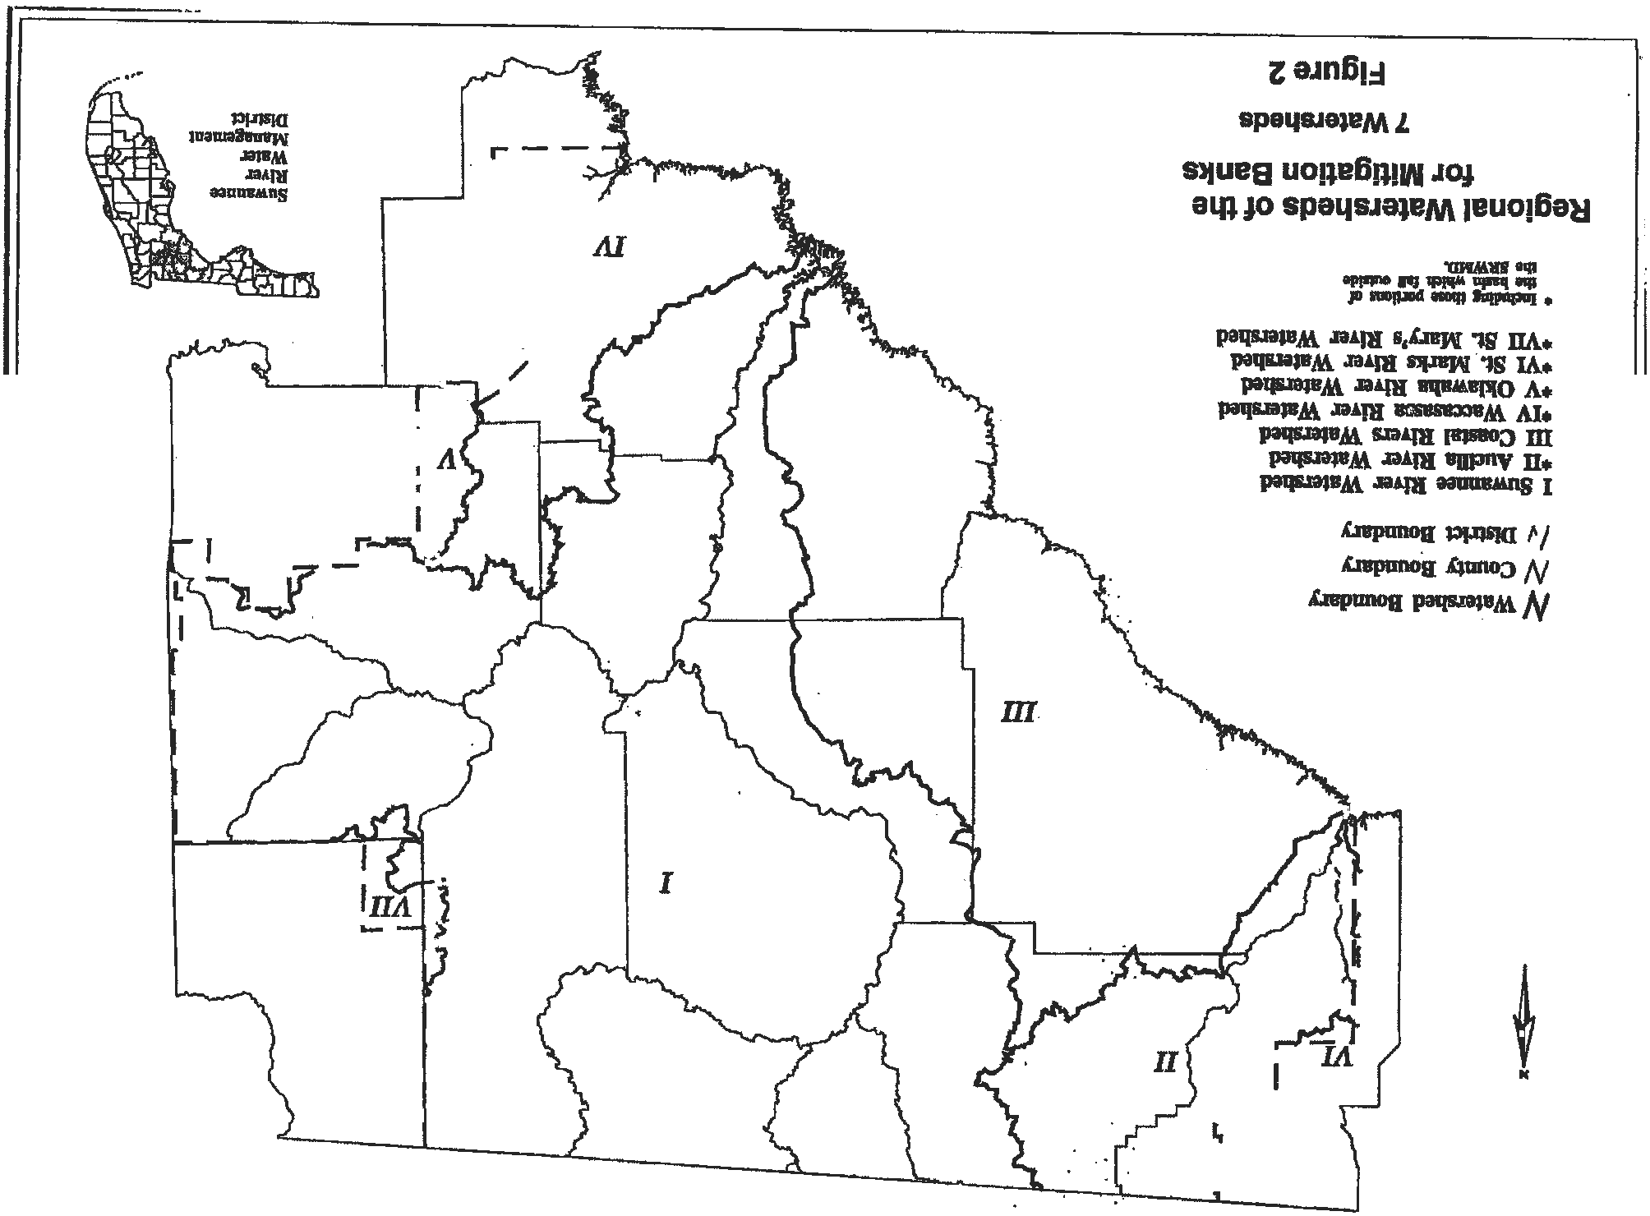



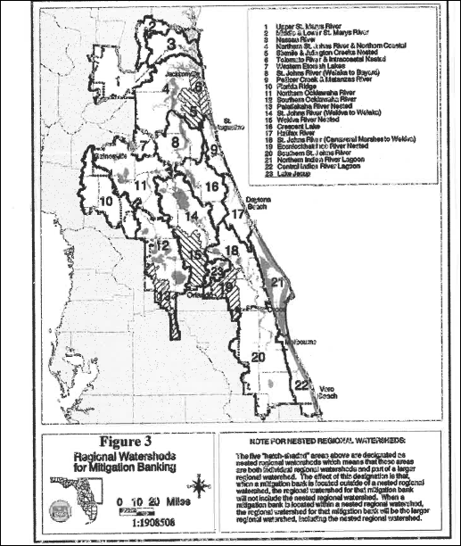


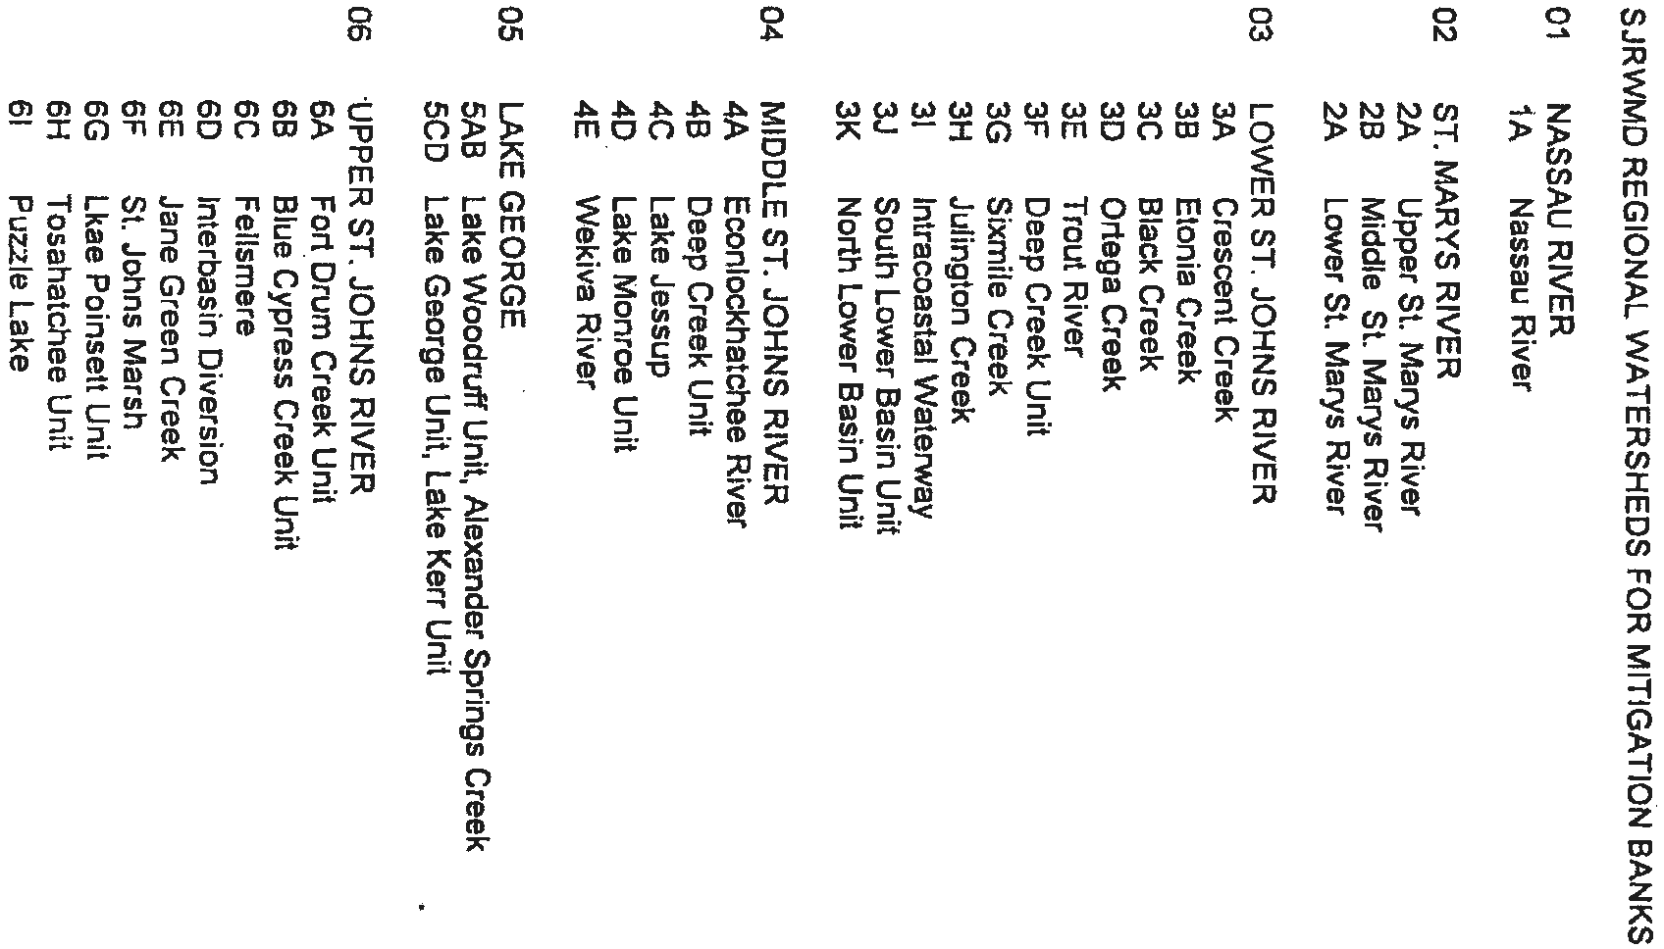


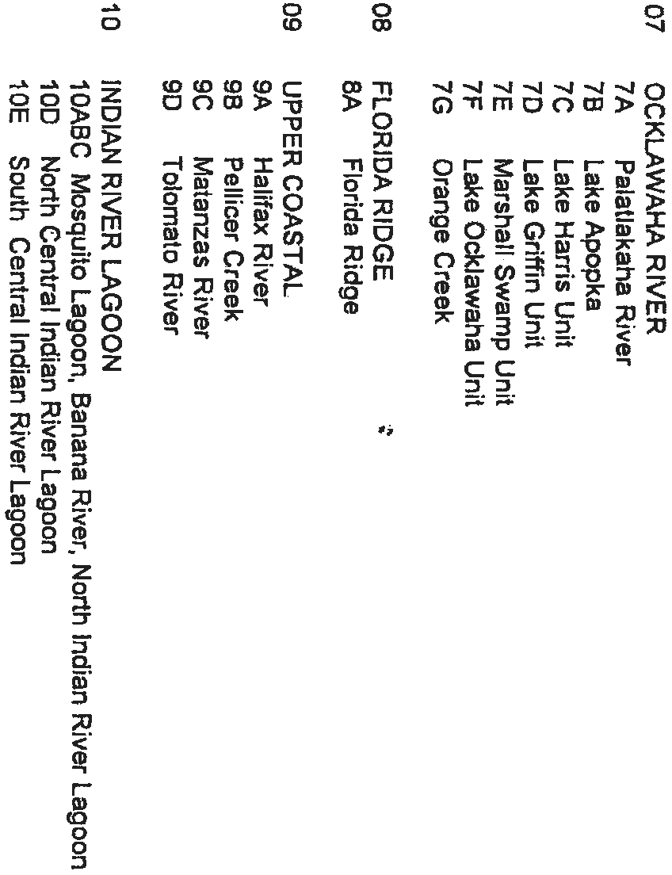

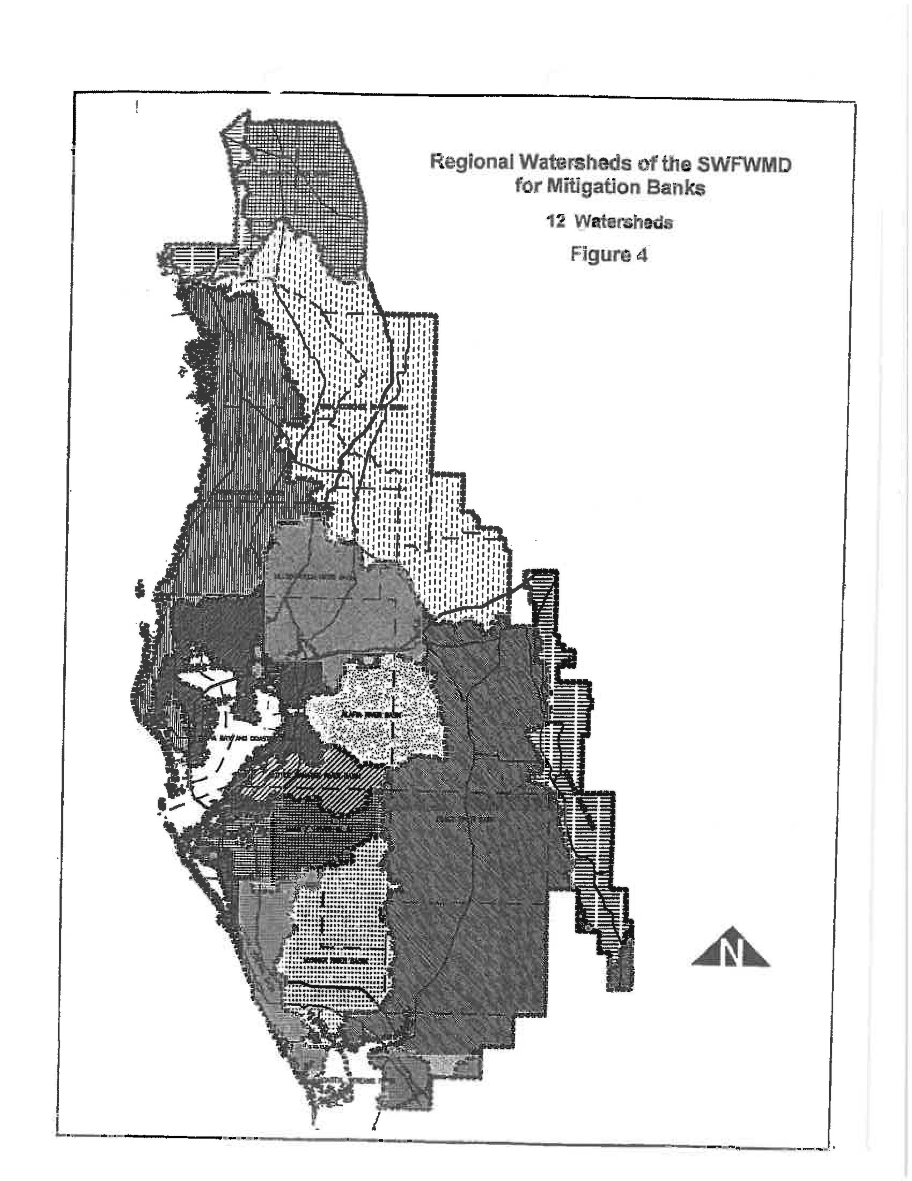
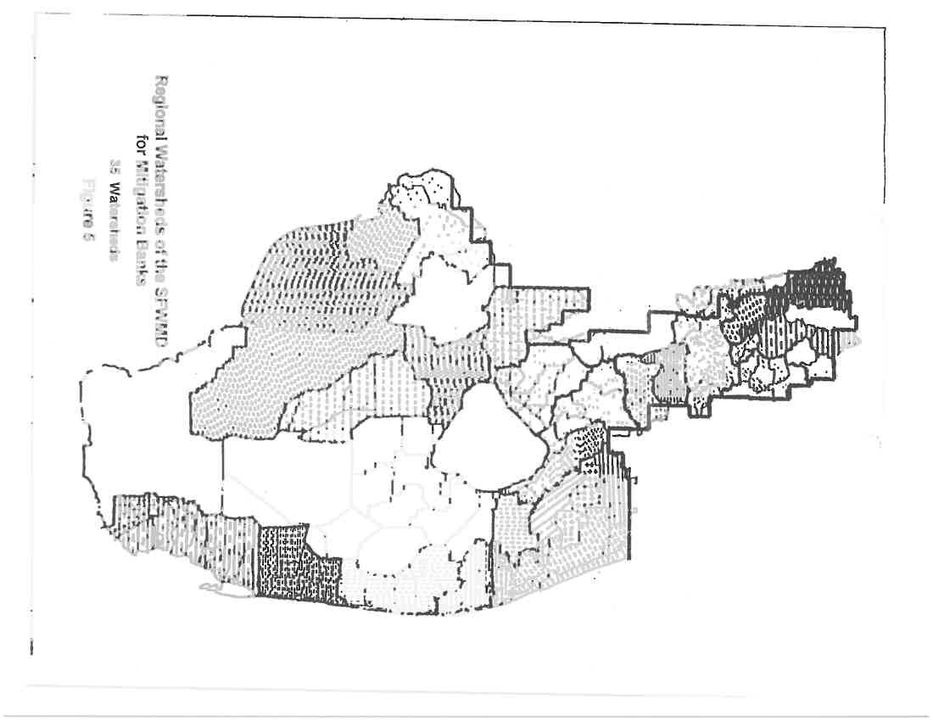


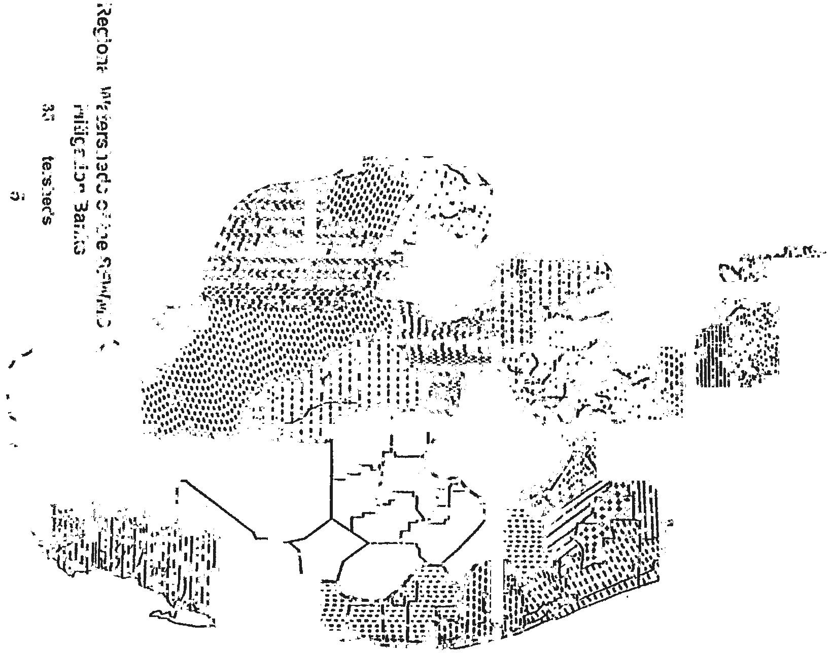





(10) “Success” means when a Mitigation Bank meets the success criteria provided in Rule 62-312.350, F.A.C., and in the Mitigation Bank Permit.
Rulemaking Authority 373.4136(11) FS. Law Implemented 373.4135, 373.4136 FS. History–New 2-2-94, Formerly 17-342.200, Amended 12-12-94, 8-21-00, 5-21-01.

62-342.300 Use of a Mitigation Bank.
Rulemaking Authority 373.4136(11) FS. Law Implemented 373.4135, 373.4136 FS. History–New 2-2-94, Formerly 17-342.300, Amended 5-21-01, Repealed 2-16-12.

62-342.400 Criteria for Establishing a Mitigation Bank.
The following criteria shall be met to establish a Mitigation Bank:
(1) The banker shall provide reasonable assurance that the proposed Mitigation Bank will:
(a) Improve ecological conditions of the regional watershed;
(b) Provide viable and sustainable ecological and hydrological functions for the proposed mitigation service area;
(c) Be effectively managed in perpetuity;
(d) Not destroy areas with high ecological value;
(e) Achieve mitigation success; and
(f) Be adjacent to lands which will not adversely affect the perpetual viability of the Mitigation Bank due to unsuitable land uses or conditions.
(2) The banker shall also provide reasonable assurance that any surface water management system to be constructed, altered, operated, maintained, abandoned, or removed within the Mitigation Bank area will meet conditions of issuance of Part IV of Chapter 373, F.S., and the rules adopted thereunder.
(3) A Mitigation Bank may be implemented in phases if each phase independently meets the requirements of subsections 62-342.400(1) and (2) above.
(4) The banker shall:
(a) Have sufficient legal or equitable interest in the property to meet the requirements of Rule 62-342.650, F.A.C.; and
(b) Meet the financial responsibility requirements of Rule 62-342.700, F.A.C.
Rulemaking Authority 373.4136(11) FS. Law Implemented 373.4135, 373.4136 FS. History–New 2-2-94, Formerly 17-342.400, Amended 5-21-01.

62-342.450 Mitigation Bank Permit and Mitigation Bank Conceptual Approval Applications.
Any person or entity proposing to establish a Mitigation Bank must apply for a Mitigation Bank Permit. An application for a Mitigation Bank Permit shall also constitute an application for any required permit authorized under Part IV of Chapter 373, F.S. Mitigation Bank Permit applications shall be processed according to Chapter 120, F.S. The Department will process and take action on all permit applications under Part IV of Chapter 373, F.S., necessary for the implementation of any Mitigation Bank for which it has permitting responsibility under the operating agreements between the Water Management Districts and the Department as authorized under Section 373.046, F.S. A person or entity who wishes to obtain an estimation of the legal and financial requirements necessary for a Mitigation Bank, information necessary for evaluation of a Mitigation Bank Permit application, and potential mitigation credits to be awarded under a Mitigation Bank Permit, may apply for a Mitigation Bank Conceptual Approval Permit. To provide the Department with reasonable assurances that the proposed Mitigation Bank will meet the criteria in Section 373.4136, F.S., and in this chapter, and that any proposed system will meet the applicable criteria of Part IV of Chapter 373, F.S., each Mitigation Bank Permit application submitted to the Department shall include the information required under Part IV of Chapter 373, F.S., as applicable, and the information specified below as appropriate for the proposed bank:
(1) A description of the location of the proposed Mitigation Bank which shall include:
(a) A map at regional scale showing the project area in relation to the regional watershed and proposed mitigation service area;
(b) A vicinity map showing the project area in relation to adjacent lands and offsite areas of ecologic or hydrologic significance which could affect the perpetual viability or ecological value of the bank;
(c) An aerial photograph identifying boundaries of the project area;
(d) A highway map showing points of access to the Mitigation Bank for site inspection; and
(e) A legal description of the proposed Mitigation Bank.
(2) A description of the ecological significance of the proposed Mitigation Bank to the regional watershed in which it is located.
(3) A description and assessment of current site conditions which shall include:
(a) A soils map of the project area;
(b) A topographic map of the project area and adjacent hydrologic contributing and receiving areas;
(c) A hydrologic features map of the project area and adjacent hydrologic contributing and receiving areas;
(d) Current hydrologic conditions in the project area;
(e) A vegetation map of the project area;
(f) Ecological benefits currently provided to the regional watershed by the project area;
(g) Adjacent lands, including existing land uses and conditions, projected land uses according to comprehensive plans adopted pursuant to Chapter 163, F.S., by local governments having jurisdiction, and any special designations or classifications associated with adjacent lands or waters; and
(h) A disclosure by the applicant of any material fact which would affect the contemplated use of the property.
(4) A mitigation plan describing the actions proposed to establish, construct, operate, manage and maintain the Mitigation Bank which shall include:
(a) Construction-level drawings detailing proposed topographic alterations and all structural components associated with proposed activities;
(b) Proposed construction activities, including a detailed schedule for implementation;
(c) The proposed vegetation planting scheme and detailed schedule for implementation;
(d) Measures to be implemented during and after construction to avoid adverse impacts related to proposed activities;
(e) A detailed perpetual management plan comprising all aspects of operation and maintenance, including water management practices, vegetation establishment, exotic and nuisance species control, fire management, and control of access; and
(f) A proposed monitoring plan to demonstrate mitigation success.
(5) An assessment of improvement or changes in ecological value anticipated as a result of proposed mitigation actions which shall include:
(a) A description of anticipated site conditions in the Mitigation Bank after the mitigation plan is successfully implemented;
(b) A comparison of current fish and wildlife habitat to expected habitat after the mitigation plan is successfully implemented; and
(c) A description of the expected ecological benefits to the regional watershed.
(6) Evidence of sufficient legal or equitable interest in the property which is to become the Mitigation Bank to meet the requirements of Rule 62-342.650, F.A.C.
(7) Draft documentation of financial responsibility meeting the requirements of Rule 62-342.700, F.A.C.
(8) Any additional information which the Department requests in order to evaluate whether the proposed Mitigation Bank meets the criteria of Section 373.4136, F.S., and this chapter.
Rulemaking Authority 373.4136(11) FS. Law Implemented 373.4135, 373.4136 FS. History–New 2-2-94, Formerly 17-342.450, Amended 12-12-94, 5-21-01.

62-342.470 Establishment of Mitigation Credits.
(1) Based upon the information submitted by the applicant, and an assessment of the proposed Mitigation Bank under the criteria of Section 373.4136, F.S., the Department will assign a number of Mitigation Credits to the proposed Mitigation Bank, or phases thereof.
(2) Mitigation Credits assigned for enhancement, restoration or preservation of wetlands or uplands will be based on the extent of improvement in ecological value resulting from these activities as determined using a functional assessment method relative to that obtained by successfully creating one acre of wetland. In determining the degree of improvement in ecological value, the following factors will be considered. However, no credits shall be released until the requirements of Rules 62-342.650 and 62-342.700, F.A.C., are met.
(a) The extent to which target hydrologic regimes can be achieved and maintained.
(b) The extent to which management activities promote natural ecological conditions, such as natural fire patterns.
(c) The proximity of the Mitigation Bank to areas with regionally significant ecological resources or habitats, such as national or state parks, Outstanding National Resource Waters and associated watersheds, Outstanding Florida Waters and associated watersheds, and lands acquired or to be acquired through governmental or non-profit land acquisition programs for environmental conservation; and the extent to which the Mitigation Bank establishes corridors for fish, wildlife or listed species to those resources or habitats.
(d) The quality and quantity of wetland or upland restoration, enhancement, preservation, or creation.
(e) The ecological and hydrological relationship between wetlands and uplands in the Mitigation Bank.
(f) The extent to which the Mitigation Bank provides habitat for fish and wildlife, especially habitat for species listed as threatened, endangered or of special concern, or provides habitats which are unique for that mitigation service area.
(g) The extent to which the lands that are to be preserved are already protected by existing state, local or federal regulations or land use restrictions.
(h) The extent that lands to be preserved would be adversely affected if they were not preserved.
(i) Any special designation or classification of the affected waters and lands.
(3) Some Mitigation Credits may be released for use prior to meeting all of the performance criteria specified in the Mitigation Bank Permit. The release of all mitigation credits awarded will only occur after the bank meets all of the success criteria specified in the permit. The number of credits and schedule for release shall be determined based upon the performance criteria for the Mitigation Bank, the success criteria for each mitigation activity, and a consideration of the factors listed in Section 373.4136(5), F.S. However, no credits shall be released until the requirements of Rules 62-342.650 and 62.342.700, F.A.C., are met. Additionally, no credits awarded for freshwater creation shall be released until the success criteria included in the Mitigation Bank Permit are met.
(4) If at any time the banker is not in material compliance with the terms of the Mitigation Bank Permit, no Mitigation Credits may be withdrawn. Mitigation Credits shall again be available for withdrawal if the banker comes back into compliance.
(5) The Mitigation Bank Permit shall contain a ledger listing the number and type of Mitigation Credits in the Mitigation Bank. The ledger will provide the maximum number and type of Mitigation Credits which would be available for withdrawal when the Mitigation Bank meets all of the performance criteria in the permit.
(6) Mitigation Credits that have been released may be used to offset adverse impacts from an activity regulated under Part IV, Chapter 373, F.S. Mitigation credits may be used in whole or in part. However, Mitigation Credits in increments of less than a hundredth of one credit shall not be used.
(7) The Department shall maintain a ledger of the Mitigation Credits available in each Mitigation Bank. Mitigation Credits shall be withdrawn as a minor modification of the Mitigation Bank Permit. To use Mitigation Credits, the impact permit applicant must submit to the agency permitting the impact, documentation from the banker demonstrating that Mitigation Credits have been reserved, sold or transferred to the permit applicant, and that the banker has requested that the Mitigation Credits be withdrawn from the Mitigation Bank. If the agency permitting the impact determines that use of the Mitigation Credits proposed by the applicant is appropriate to offset the adverse impacts, it shall notify the Department. Upon receipt of this notice, the Department shall determine if a sufficient number and type of Mitigation Credits are available, withdraw the Mitigation Credits as a minor modification of the Mitigation Bank Permit, and notify the agency permitting the impact and the banker by letter of the withdrawal of the Mitigation Credits and the remaining balance of Mitigation Credits.
(8) When the Department or the District is the banker, each agency shall maintain its own ledger. The District shall annually submit a report of the Mitigation Credits sold, transferred, or used from its Mitigation Bank to the Department.
Rulemaking Authority 373.4136(11) FS. Law Implemented 373.4135, 373.4136 FS. History–New 2-2-94, Formerly 17-342.470, Amended 5-21-01.

62-342.600 Mitigation Service Area.
(1) A Mitigation Service Area will be established for each Mitigation Bank in the Mitigation Bank Permit under the criteria of Section 373.4136(6), F.S. Except as provided herein, Mitigation Credits may only be withdrawn to offset adverse impacts in the Mitigation Service Area. The boundaries of the Mitigation Service Area shall depend upon the geographic area where the Mitigation Bank could reasonably be expected to offset adverse impacts.
(2) A Mitigation Service Area may be larger than the regional watershed if the Mitigation Bank provides exceptional ecological value such that adverse impacts to wetlands outside the regional watershed could reasonably be expected to be adequately offset by the Mitigation Bank because of local ecological or hydrological conditions. A Mitigation Service Area may be smaller than a regional watershed, if adverse impacts throughout the regional watershed cannot reasonably be expected to be offset by the Mitigation Bank because of local ecological or hydrological conditions.
(3) Mitigation Service Areas may overlap and Mitigation Service Areas for two or more Mitigation Banks may be approved for a regional watershed.
(4) If the requirements in Rule 62-342.300, F.A.C., are met, the following projects or activities shall be eligible to use a Mitigation Bank, notwithstanding the fact that they are not completely located within the Mitigation Service Area:
(a) Projects with adverse impacts partially located within the Mitigation Service Area.
(b) Linear projects, such as roadways, transmission lines, distribution lines, pipelines, or railways.
(c) Projects with total adverse impacts of less than one-half acre in size.
(5) When Mitigation Credits are applied to offset adverse impacts within the same regional watershed as the Mitigation Bank, the Mitigation Credit requirement shall be the same as that specified for mitigation on the project site.
(6) When Mitigation Credits are applied to offset adverse impacts outside the regional watershed, the Mitigation Credit requirement shall be higher than that specified for mitigation on the project site if necessary to adequately offset the adverse impacts of the project, except for linear projects, as referenced in paragraph (4)(b) above, when the impact being offset is within the Mitigation Service Area of the Mitigation Bank to be used.
Rulemaking Authority 373.4136(11) FS. Law Implemented 373.4135, 373.4136 FS. History–New 2-2-94, Formerly 17-342.600, Amended 12-12-94, 5-21-01.

62-342.650 Land Use Restrictions on Mitigation Banks.
(1) Before Mitigation Credits may be used from a Mitigation Bank or any phase of a Mitigation Bank, the banker shall either (a) cause a fee interest to be conveyed to the Board of Trustees of the Internal Improvement Trust Fund (“Board of Trustees”), or (b) cause a conservation easement to be conveyed to both the Department and the District. The grantor of a conservation easement may convey a conservation easement to additional grantees, but such conveyance shall be subordinate to the conservation easement granted to the Department and the District. Mitigation Banks on Federal, state, or water management district owned land shall be encumbered in perpetuity by conservation easements, or other mechanisms shall be employed to ensure preservation according to the Mitigation Bank permit.
(2) If the Mitigation Bank is located within an area identified in a Department acquisition plan, and the Department determines that the ecological value of the bank can be increased by incorporating the bank into the Department’s land management programs, the Department may award additional mitigation credits if the fee interest in the bank is conveyed to the Department as opposed to a conservation easement.
(3) All conservation easements shall be granted in perpetuity without encumbrances, unless such encumbrances do not adversely affect the ecological viability of the Mitigation Bank. All conservation easements shall be of a form and content sufficient to ensure preservation of the Mitigation Bank according to the permit, and shall, at a minimum, meet requirements and restrictions of Section 704.06, F.S., except as provided in subsection 62-342.650(9), F.A.C. The conservation easement shall also provide that the banker shall have access to the property and the authority to perform all acts necessary to ensure compliance with the Mitigation Bank Permit (unless the banker is the fee owner of the property), and that the Department shall have access and the authority to perform these acts if the banker fails to do so.
(4) All real property conveyances of the fee interest shall be in fee simple and by statutory warranty deed, without encumbrances that adversely affect the integrity of the bank and are acceptable to the Board of Trustees. The Board of Trustees will accept a quit claim deed to aid in clearing minor title defects or otherwise resolve a boundary question in the Mitigation Bank.
(5) As part of providing reasonable assurance that the Mitigation Bank site will be preserved in perpetuity, the grantor of the property or conservation easement shall provide the following unless the Department determines during the permit review process such items are not necessary to ensure preservation of the Mitigation Bank according to the permit:
(a) A boundary survey of the real property interest being conveyed. The survey must be certified, by a land surveyor and mapper, registered in the State of Florida, to meet the requirements of the Department and the minimum technical standards set forth by the Florida Board of Professional Land Surveyors and mappers in Chapter 61G17-6, F.A.C., under Section 472.027, F.S.
(b) A certified appraisal or other documentation demonstrating the market value of the property or interest to be conveyed to determine the appropriate amount of title insurance.
(c) A marketable title commitment issued to the Department as beneficiary in an amount at least equal to the fair market value, as established in paragraph 62-342.650(4)(b), F.A.C., of the interest being conveyed. An owner’s title insurance policy (ALTA Form B) naming the Department as beneficiary shall be issued to the Department within the time frames specified by the permit. The coverage, form and exceptions of the title insurance policy shall ensure that the Mitigation Bank will be preserved according to the Mitigation Bank Permit.
(d) A Phase I environmental audit identifying any environmental problems which may affect the liability of the Department or Board of Trustees and any additional audits as are necessary to ensure that the Department or the Board of Trustees is not subject to liability under Federal or State laws relating to the treatment or disposal of hazardous substances or ownership of land upon which hazardous substances are located, or to ensure that there are not hazardous substances present on the property which would adversely affect construction, implementation, and perpetual management of the Mitigation Bank.
(6) The Department shall require additional documentation or actions from the grantor of the conservation easement or fee interest if such additional documentation or actions are necessary to ensure that the Mitigation Bank will be preserved according to the Mitigation Bank permit.
(7) The banker shall pay the documentary revenue stamp tax and all other taxes or costs associated with the conveyance, including the cost of recording the deed or conservation easement and any other recordable instruments required by the Department or Board of Trustees, unless prohibited or exempt by law, as a condition of the receipt of the conveyance.
(8) All real estate taxes and assessments which are or which may become a lien against the property shall be satisfied of record by the banker before recording the conservation easement. If necessary, the banker shall, in accordance with Section 196.295, F.S., place funds in escrow with the county tax collector. The mitigation banker shall also provide the Department with annual documentation demonstrating that such taxes and assessments have been paid.
(9) As a condition of receipt of the conveyance the banker shall remove all abandoned personal property, solid waste, or hazardous substances from the property that: reduces the proposed ecological value of the property; will adversely affect the construction, implementation or management of the bank; will adversely affect the construction, alteration, operation, maintenance, abandonment or removal of any surface water management system to be constructed in the bank; or poses a risk of liability to the Board of Trustees or the Department.
(10) The banker shall record the conservation easement or property deed required in the Mitigation Bank Permit. The banker shall submit to the Department the original recorded conservation easement or property deed as soon as such document is returned from the public records office.
Rulemaking Authority 373.4136(11) FS. Law Implemented 373.4135, 373.4136 FS. History–New 2-2-94, Formerly 17-342.650, Amended 12-12-94, 5-21-01.

62-342.700 Financial Responsibility.
(1) To provide reasonable assurances that the proposed Mitigation Bank will meet the requirements of Section 373.4136, F.S., this section and the associated permit conditions, non-governmental bankers shall provide proof of financial responsibility for: (a) the construction and implementation phase of the bank, and (b) the perpetual management of the bank, as required in this section. Governmental entities shall provide proof of financial responsibility under subsection 62-342.700(12), F.A.C. The amount of financial responsibility provided in the mechanisms required in this section shall be based on the cost estimates determined under subsection 62-342.700(10), F.A.C.
(2) Submitting Financial Responsibility Documentation. The applicant shall provide draft documentation of the required financial responsibility mechanisms described below with the permit application, and shall submit to the Department the executed or finalized documentation within the time frames specified in the permit. The provisions of this section shall also apply for any modifications to the Mitigation Bank Permit.
(3) General Terms for Financial Responsibility Mechanisms. In addition to the specific provisions regarding financial responsibility mechanisms for construction and implementation in subsection 62-342.700(4), F.A.C., and perpetual management in subsection 62-342.700(9), F.A.C., the following terms shall be complied with:
(a) The financial responsibility mechanisms shall be payable at the direction of the Department to its designee or to a standby trust agreement. The financial responsibility mechanism shall be retained by the Department if it is of a type which is retained by the beneficiary according to industry standards.
(b) Demonstration of financial responsibility shall be continuous until complete satisfaction of the applicable permit conditions and approved release of financial responsibility by the Department.
(c) All financial mechanisms must guarantee that the banker will perform all of its obligations under the permit, provide alternative financial assurance of a type allowed by this section, and obtain the Department’s written approval of the alternative assurance provided within 90 days after receipt by both the banker and the Department of a notice of cancellation of a bond or intent not to extend the expiration date of a letter of credit.
(d) A banker may satisfy the requirements of this section by establishing more than one acceptable financial mechanism per Mitigation Bank.
(e) A banker may use a financial assurance mechanism allowed under this section for more than one Mitigation Bank. The amount of funds available through the mechanism must be no less than the sum of funds that would be available through separate mechanisms acceptable for each Mitigation Bank.
(f) A banker must notify the Department by certified mail within 10 days after the commencement of a voluntary or involuntary proceeding:
1. To dissolve the banker,
2. To place the banker in receivership,
3. For entry of an order for relief against the banker under Title 11 of the United States Code, or
4. A general assignment of its assets for the benefit of creditors under Chapter 727, F.S.
A banker may not assign its assets for the benefit of creditors. A banker will be without the required financial assurance in the event of a bankruptcy of the trustee of any trust provided under this rule, or the suspension or revocation of the authority of any trustee to act as trustee, or in the event of a bankruptcy of the issuing institution of any bond or letter of credit, or the revocation of the authority of such institution to issue such instruments. The banker must notify the Department within 10 days, and establish other financial assurance within 60 days after such an event.
(4) Financial Responsibility for Construction and Implementation.
(a) No financial responsibility shall be required where the construction and implementation of the Mitigation Bank, or a phase thereof, is completed and successful prior to the withdrawal of any credits.
(b) Financial responsibility for the construction and implementation of each phase of the Mitigation Bank may be established by surety bonds, performance bonds, irrevocable letters of credit, or trust funds. If a bond or an irrevocable letter of credit is used as the financial mechanism, a standby trust fund shall be established, in which all payments under the bonds or irrevocable letter of credit shall be directly deposited.
(c) The amount of financial responsibility established shall equal 110% of the cost of construction and implementation of the Mitigation Bank (or each phase of the Mitigation Bank) which is being constructed and implemented. When the bank (or appropriate phase) has been completely constructed, implemented, and is trending toward success in compliance with the permit, the respective amount of financial responsibility shall be released.
(d) The financial responsibility mechanism shall become effective prior to the release of any mitigation credits.
(5) Surety or Performance Bond.
(a) A banker may satisfy the requirements of subsection 62-342.700(4), F.A.C., by obtaining a surety or performance bond that conforms to the requirements of this subsection. The company issuing the bond must be licensed to do business in Florida, and be among those listed as acceptable sureties on federal bonds in the latest Circular 570 of the U.S. Department of the Treasury, or a Florida-domiciled surety or insurance company with at least an A rating in the latest printing of the A.M. Best’s Key Rating Guide to write individual bonds up to 10 percent of the policyholder’s surplus. The banker shall provide proof that the bond company meets these requirements.
(b) The surety or performance bond shall be worded in substantial conformance with Form 62-342.900(1). Deviations from the form shall be identified and submitted to the Department for review and approval.
(c) Under the terms of the bond, the surety shall become liable on the bond obligation when the mitigation banker fails to perform under the terms of the Mitigation Bank Permit. In all cases, the surety’s liability shall be limited to the sum stated in the bond.
(d) The mitigation banker who uses a surety or performance bond to satisfy the requirements of subsection 62-342.700(4), F.A.C., must establish a standby trust fund when the surety or performance bond is acquired. Under the terms of the bond, all amounts paid by the surety under the bond will be deposited directly into the standby trust fund for distribution by the trustee in accordance with the Department’s instructions. The standby fund agreement must meet the requirements specified in subsection 62-342.700(7), F.A.C.
(e) The bonding company shall provide notice of cancellation of a bond by certified mail to the banker and to the Department. Cancellation may not occur, however, during the 120 days beginning on the date of receipt of the notice of cancellation by both the banker and the Department, as evidenced by the return receipt.
(f) A bond may be canceled by the banker if the Department has given prior written consent. The Department shall provide such consent when either the banker substitutes alternative financial assurance allowed under this rule and such alternate financial assurance is approved by the Department and is effective or the Department releases the banker from the requirements of this subsection.
(6) Irrevocable Letter of Credit.
(a) A mitigation banker may satisfy the requirements of subsection 62-342.700(4), F.A.C., by obtaining an irrevocable letter of credit that conforms to the requirements of this subsection. The irrevocable letter of credit shall be provided by a federally insured depository that is “well capitalized” or “adequately capitalized” as defined in Section 38 of the Federal Deposit Insurance Act (12 USC 1831(o)). The banker shall submit proof of such capitalization to the Department.
(b) The irrevocable letter of credit shall be worded in substantial conformance with Form 62-342.900(2). Deviations from the form shall be identified and submitted to the Department for review and approval.
(c) A mitigation banker who uses an irrevocable letter of credit to satisfy the requirements of subsection 62-342.700(4), F.A.C., must also establish a standby trust fund when the irrevocable letter of credit is acquired. Under the terms of the irrevocable letter of credit, all amounts paid pursuant to a sight draft by the Department will be deposited by the issuing institution directly into the standby trust fund to be distributed by the trustee in accordance with instructions from the Department. This standby trust fund must meet the requirements specified in subsection 62-342.700(7), F.A.C.
(d) Letters of credit must be irrevocable and issued for a period of at least one year, and the expiration date must be automatically extended for a period of at least one year unless, at least 120 days prior to the expiration date, the issuing institution notifies both the banker and the Department by certified mail of a decision not to extend the expiration date. The terms of the irrevocable letter of credit must provide that the 120 days begins on the date when both the banker and the Department have received the notice, as evidenced by the return receipts.
(7) Standby Trust Fund.
(a) A mitigation banker using a surety or performance bond or irrevocable letter of credit shall contemporaneously establish a standby trust fund. The trustee of the standby trust shall be an entity that has the authority to act as a trustee and whose trust operations are regulated and examined by a Federal agency or an agency of the state in which the fund is established. The banker shall provide proof of such regulation and examination to the Department.
(b) The standby trust agreement shall be worded in substantial conformance with Form 62-342.900(3). Deviations from the form shall be identified and submitted to the Department for review and approval.
(8) Trust Fund.
(a) A mitigation banker may satisfy the requirements of subsection 62-342.700(4), F.A.C., by establishing a trust fund that conforms to the requirements of this section. The trustee of the trust fund shall be an entity that has the authority to act as a trustee and whose trust operations are regulated and examined by a Federal agency or an agency of the state in which the fund is established. The banker shall provide proof of such regulation and examination to the Department.
(b) The trust agreement must be worded in substantial conformance to Form 62-342.900(4). Deviations from the form shall be identified and submitted to the Department for review and approval.
(9) Financial Responsibility for Perpetual Management.
(a) A banker shall establish either a trust fund or an irrevocable letter of credit or surety or performance bond with a corresponding standby trust fund to provide financial responsibility for the perpetual management of the Mitigation Bank, or phase thereof. When a trust fund is used, the requirements of subsection 62-342.700(8), F.A.C., must be met. When a surety or performance bond or irrevocable letter of credit is used with a standby trust fund, the requirements of subsections 62-342.700(6), 62-342.700(5), and 62-342.700(7), F.A.C., respectively, must be met, except all references to construction and implementation shall be changed to perpetual management. Trust fund agreements for perpetual management shall be worded in substantial conformance with Form 62-342.900(5). Deviations from the form shall be identified and submitted to the Department for review and approval.
(b) The amount of financial responsibility provided shall be sufficient to be reasonably expected to generate annual revenue equal to the annual cost of perpetual management, established under subsection 62-342.700(10), F.A.C., at an assumed average rate of return of six percent per annum, for the bank, or for banks constructed in phases, for all phases for which credits have been released.
(c) The financial responsibility mechanism must be in effect prior to the withdrawal of credits from the Mitigation Bank, or applicable phase thereof.
(10) Cost estimates.
(a) For the purposes of determining the amount of financial responsibility that is required in this section, the banker shall submit a detailed written estimate, in current dollars, of the total cost of construction and implementation and of the cost of perpetual management of the Mitigation Bank. The written cost estimate shall be certified by a licensed professional whose license authority in the State of Florida includes the ability to provide such certified written estimates.
(b) The cost estimate for construction and implementation shall include all costs associated with completing construction and implementation of the Mitigation Bank, or phase thereof, including, as applicable, earthmoving, planting, exotic/nuisance vegetation removal, land surveying, structure installation, consultant fees, taxes, monitoring activities and reports.
(c) The cost estimate for the perpetual management of the Mitigation Bank shall be based on the costs of maintaining and operating any structures, controlling nuisance or exotic species, fire management, consultant fees, monitoring activities and reports, taxes, and any other costs associated with perpetual management. The amount of financial responsibility shall equal the cost of perpetual management for the bank, or, for banks constructed in phases for all phases for which credits have been released.
(d) The banker shall submit written cost estimates, together with verifiable basis for the estimates to the Department along with the financial responsibility mechanism.
(e) The costs shall be estimated based on a third party performing the work at the fair market value of services. The source of any cost estimates shall be indicated.
(11) Cost adjustments.
(a) Every two years, the banker shall undertake an estimate of the costs of the remaining construction, implementation, and perpetual management. The banker shall submit the estimate to the Department in writing certified by a licensed professional whose license authority in the State of Florida includes the ability to provide such certified written estimates accompanied by supporting documentation. Construction, implementation, and perpetual management costs shall be listed separately. The Department shall review the cost adjustment statement and supporting documentation to determine if they reflect all construction, implementation, and perpetual management costs. If the cost adjustment statement and supporting documentation accurately reflects a good faith estimate of all construction, implementation and perpetual management costs, the Department shall approve the cost adjustment statement.
(b) At each cost adjustment, the banker shall revise the construction, implementation, and perpetual management cost estimate for inflation and changes in the costs to complete or undertake the current phase of the Mitigation Bank or appropriate phase thereof.
(c) Revised cost estimates shall be used as the basis for modifying the financial mechanism. If the value of the financial mechanism is less than the total amount of the current construction and implementation and perpetual management cost estimates, the banker shall, upon Department approval of the cost adjustment statement, increase the value of the financial mechanism to reflect the new estimate within 60 days. If the value of the funding mechanism is greater than the total amount of the current cost estimate, the banker may reduce the value of the funding mechanism to reflect the new estimate upon receiving Department approval of the cost adjustment statement.
(d) The Department shall require adjustment of the amount of financial responsibility provided for construction, implementation or perpetual management at times other than the cost adjustment period when the estimated costs associated with compliance with the permit conditions exceed the current amount of financial responsibility and such financial assurances are deemed necessary to ensure compliance with the permit conditions.
(e) The banker may provide revised cost estimates more frequently than every two years. If at any time the banker learns that actual costs exceed estimated costs by more than 25 percent, the banker shall provide a revised cost estimate and adjust the corresponding amount of financial responsibility under this section.
(12) Financial Responsibility for Governmental, Non-Department and Non-Water Management District, Mitigation Banks.
(a) Governmental entities other than the Department or Districts shall demonstrate reasonable assurances that it can meet the construction and implementation requirements in the Mitigation Bank Permit by any of the mechanisms in subsection 62-342.700(4), F.A.C., above, or by other financial mechanisms which are sufficient to meet the requirements of this section.
(b) Governmental entities other than the Department or District shall establish a trust fund for the perpetual management of the Mitigation Bank which meets the requirements of subsection 62-342.700(9), F.A.C., above. The trust fund for perpetual management may be funded as Mitigation Credits are withdrawn, provided that the trust fund is fully funded when all Mitigation Credits are withdrawn. Governmental entities shall comply with the cost adjustment provisions in subsection 62-342.700(11), F.A.C.
Rulemaking Authority 373.4136(11) FS. Law Implemented 373.4135, 373.4136 FS. History–New 2-2-94, Formerly 17-342.700, Amended 12-12-94, 9-12-95, 5-21-01.

62-342.750 Mitigation Bank Permit and Mitigation Bank Conceptual Approval.
If the Mitigation Bank proposal meets the criteria of Section 373.4136, F.S., Chapters 62-330, 62-341, and 62-343, F.A.C., and this chapter, the Department shall issue a Mitigation Bank Permit to the banker. An authorization under this section may be issued in two forms: a Mitigation Bank Permit or a Mitigation Bank Conceptual Approval.
(1) The Mitigation Bank Permit authorizes the establishment, implementation and operation of the Mitigation Bank, authorizes the construction, alteration, operation, maintenance, abandonment or removal of any surface water management system proposed within the Mitigation Bank, and sets forth the rights and responsibilities of the banker and the Department for the implementation, management, maintenance and operation of the Mitigation Bank. The Mitigation Bank Permit shall include the following:
(a) A description of the Mitigation Service Area.
(b) The maximum number of Mitigation Credits available for use when the Mitigation Bank, or phase thereof, is deemed successful, the type of Mitigation Credits awarded, and the number and schedule of Mitigation Credits available for use prior to success.
(c) The success criteria by which the Mitigation Bank will be evaluated. “Success” means when a Mitigation Bank meets the success criteria provided in Rule 62-312.350, F.A.C., and in the Mitigation Bank Permit.
(d) The financial responsibility mechanism(s) which must be employed by the banker, and provisions for adjustment of the financial responsibility mechanism.
(e) Requirements for the execution and recording of the conservation easement or conveyance of the fee interest as provided in Rule 62-342.650, F.A.C.
(f) A ledger listing Mitigation Credits available in the Mitigation Bank.
(g) A schedule for implementation of the Mitigation Bank, and any phases therein.
(h) The perpetual management requirements for the mitigation bank.
(i) The conditions required under Chapters 62-330, 62-341, and 62-343, F.A.C., as applicable, for construction, alteration, operation, maintenance, abandonment or removal of any surface water management system proposed within the Mitigation Bank.
(2) A Mitigation Bank Permit shall automatically expire five years from the date of issuance if the banker has not recorded a conservation easement or conveyed fee simple interest, as appropriate, over the real property within the Mitigation Bank, or phase thereof, in accordance with the Mitigation Bank Permit; or, when no property interest is required to be recorded, the Mitigation Bank Permit shall automatically expire if no construction has been commenced pursuant thereto. Except as provided above, a Mitigation Bank Permit shall be perpetual unless revoked or modified.
(3) A Mitigation Bank Conceptual Approval estimates the legal and financial requirements necessary for the Mitigation Bank, information necessary for evaluation of the Mitigation Bank Permit application, and potential Mitigation Credits to be awarded pursuant to the Mitigation Bank Permit. The Mitigation Bank Conceptual Approval does not authorize the use or withdrawal of Mitigation Credits, or any construction within the Mitigation Bank. The level of detail provided in the Mitigation Bank Conceptual Approval will depend on the level of detail submitted with the application. A Mitigation Bank Conceptual Approval shall be valid for a term of five years from the date of issuance.
Rulemaking Authority 373.4136(11) FS. Law Implemented 373.4135, 373.4136 FS. History–New 2-2-94, Formerly 17-342.750, Amended 5-21-01.

62-342.800 Surrender, Transfer, or Modification of Mitigation Bank Permits.
(1) If no credits have been used or sold, a banker may apply to surrender a Mitigation Bank permit, or permitted phase thereof, by submitting a written request to the Department. The written request must identify which phase of the Mitigation Bank will be surrendered, indicate the extent of mitigation work performed in that phase, and describe the conservation property interest encumbering that phase. The Department shall authorize release from a Mitigation Bank permit when no credits have been used, and relinquishment of the phase would not compromise the ecological value of the remaining portions of the Mitigation Bank. A surrender and release of a geographic phase of a Mitigation Bank shall be made by modification of the Mitigation Bank Permit.
(2) If a property interest has been conveyed as provided in Rule 62-342.650, F.A.C., for a Mitigation Bank permit which is surrendered as provided above, the Department shall convey the property interest back to the grantor of that interest.
(3) If a surface water management system has been constructed or altered within the Mitigation Bank, the banker shall obtain any permits required under Sections 373.413, 373.414, and 373.426, F.S., and Chapters 62-330, 62-341, and 62-343, F.A.C., to operate or abandon the surface water management system.
(4) To transfer a Mitigation Bank Permit, the banker shall meet the requirements of Chapter 62-343, F.A.C., and the entity to whom the permit will be transferred must provide reasonable assurances that it can meet the requirements of the permit. If the transfer to the Department is proposed, the current banker shall provide an updated cost estimate and adjust the final responsibility mechanism, as appropriate, prior to transfer of the permit.
(5) A Mitigation Bank Permit can be issued as a modification of a Mitigation Bank Conceptual Approval.
Rulemaking Authority 373.4136(11) FS. Law Implemented 373.4135, 373.4136 FS. History–New 2-2-94, Formerly 17-342.800, Amended 12-12-94, 5-21-01.

62-342.850 Water Management District Mitigation Banks.
The District may construct, operate, manage, and maintain a Mitigation Bank under this section after obtaining a Mitigation Bank Permit from the Department.
(1) A District may apply to establish a Mitigation Bank by submitting a Mitigation Bank plan, meeting the applicable permitting criteria of this section, in one of the following formats:
(a) A Mitigation Bank plan identifying one or more parcels of lands to be acquired for mitigation site(s).
(b) A Mitigation Bank plan identifying one or more parcels of land in which the District has a legal or equitable interest.
(2) Land Use Restrictions on District Mitigation Banks. The District shall maintain the land within the Regional Mitigation Bank pursuant to the terms of the Mitigation Bank Permit. Any change in the land use shall require a modification of the Mitigation Bank Permit.
(3) Notwithstanding any other provision of this chapter, the District may sell, transfer, or use Mitigation Credits prior to acquiring the proposed mitigation site as set forth in its Mitigation Bank Permit.
(4) District Financial Responsibility. A portion of the funds contributed to a District Mitigation Bank from the sale of credits shall be dedicated for the construction and implementation of the Mitigation Bank, and a portion of the funds shall be dedicated for the long-term management of the bank as set forth in the Mitigation Bank Permit. Funds derived from the sale of Mitigation Credits which are not necessary for the construction, implementation, and long-term management of a District Regional Mitigation Bank shall be dedicated for the initiation of other District Mitigation Banks, or expansion of other District land acquisition or restoration projects which improve regional ecological conditions.
(5) Procedures for Establishment of Mitigation Banks. Mitigation Banks established by the Districts shall be permitted, as applicable, under the procedures in the Operating Agreements Concerning Environmental Resource Permitting, Management and Storage of Surface Waters Regulation, and Wetland Resource Regulation, as adopted by the Department in subsections 62-113.100(3)(e), (k), (p), and (t), F.A.C.
(6) Each Water Management District is encouraged to establish at least two mitigation banks in the District not later than January 1, 1995, or report to the Secretary as to why such mitigation banks have not been established, any attendant problems to establishing such mitigation banks, and a proposed time frame for establishment of such banks.
Rulemaking Authority 373.4136(11) FS. Law Implemented 373.4135, 373.4136 FS. History–New 2-2-94, Formerly 17-342.850, Amended 12-12-94, 5-21-01.

62-342.900 Mitigation Banking Forms.
The forms and instructions used by the Department in the Mitigation Banking program are adopted and incorporated by reference in this section. The forms are listed by rule number, which is also the form number, and with the subject title and effective date. Copies of forms may be obtained by telephoning or writing to the Bureau of Submerged Lands and Environmental Resources, MS 2500, Department of Environmental Protection, 2600 Blair Stone Road, Tallahassee, Florida 32399, (850)488-6579.
(1) Mitigation Bank Performance Bond to Demonstrate Construction and Implementation Financial Assurance.
(2) Mitigation Bank Irrevocable Letter of Credit to Demonstrate Construction/Implementation Financial Assurance.
(3) Mitigation Bank Standby Trust Fund Agreement to Demonstrate Construction/Implementation Financial Assurance.
(4) Mitigation Bank Trust Fund Agreement to Demonstrate Construction/Implementation Financial Assurance.
(5) Mitigation Bank Trust Fund Agreement to Demonstrate Perpetual Management Financial Assurance.
(6) Mitigation Bank Standby Trust Fund Agreement to Demonstrate Perpetual Management Financial Assurance.
Rulemaking Authority 373.4136(11) FS. Law Implemented 373.4135, 373.4136 FS. History–New 5-21-01.

