68D-24.155 St. Johns County Boating Restricted Areas.
(1) For the purpose of regulating speed and operation of vessel traffic on the Florida Intracoastal Waterway within St. Johns County, Florida, the following boating restricted areas are established:
(a)1. S. R. 210 – Palm Valley Bridge – An Idle Speed No Wake boating restricted area shoreline to shoreline, in and adjacent to the Florida Intracoastal Waterway, 500’ north of the centerline of the S. R. 210 Bridge, south to 500’ south of the centerline of the S. R. 210 Bridge, as depicted in Drawing A.
2. Vilano Beach Bridge (Tolomato River) – An Idle Speed No Wake boating restricted area shoreline to shoreline, in and adjacent to the Florida Intracoastal Waterway, 500’ north of the centerline of the Vilano Beach Bridge, south to 500’ south of the centerline of the Vilano Beach Bridge, as depicted in Drawing B.
3. Bridge of Lions (Matanzas River) – An Idle Speed No Wake boating restricted area shoreline to shoreline, in and adjacent to the Florida Intracoastal Waterway, 500’ north of the centerline of the Bridge of Lions Bridge, south to 500’ south of the centerline of the Bridge of Lions Bridge, as depicted in Drawing C.
4. S. R. 312 Bridge (Matanzas River) – An Idle Speed No Wake boating restricted area shoreline to shoreline, in and adjacent to the Florida Intracoastal Waterway, 500’ north of the centerline of the S. R. 312 Bridge, south to 500’ south of the centerline of the S. R. 312 Bridge, as depicted in Drawing D.
5. Crescent Beach Bridge at S. R. 206 (Mantanzas River) – An Idle Speed No Wake boating restricted area in and adjacent to the Florida Intracoastal Waterway, 500’ north of the Crescent Beach Bridge, south to 500’ south of the centerline of the Crescent Beach Bridge, as depicted in Drawing E.
6. Devil’s Elbow Boat Ramp – A Slow Speed Minimum Wake zone from 500 feet north (29°45’16N”/81°14’58W”) of the centerline of the Devil’s Elbow Boat Ramp to 500 feet south (29°45’07N”/81°14’59W”) of the centerline of the Devil’s Elbow Boat Ramp in and adjacent to the Florida Intracoastal Waterway as depicted in Drawing F.
(b) St. Johns County is authorized to install and maintain appropriate regulatory markers as directed by the Division of Law Enforcement within the boating restricted areas. St. Johns County may enter into agreements with public or private organizations or individuals to effect this purpose.
(2) The boating restricted areas are depicted on the following drawings:

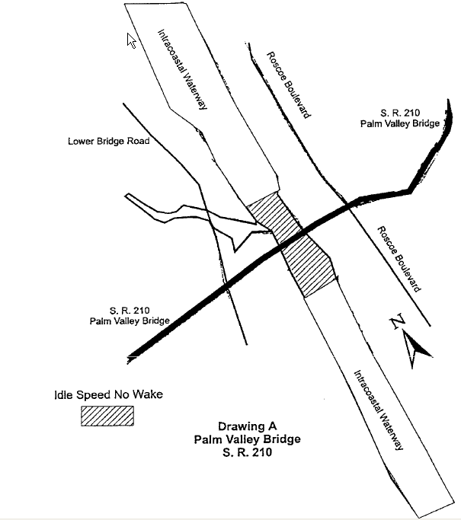

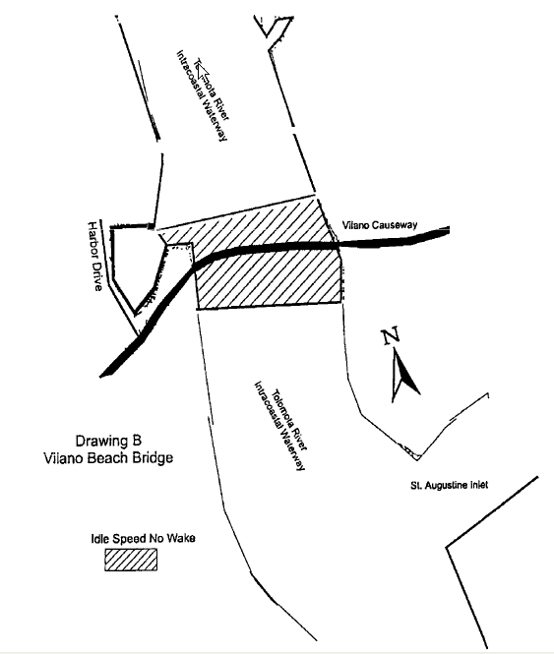

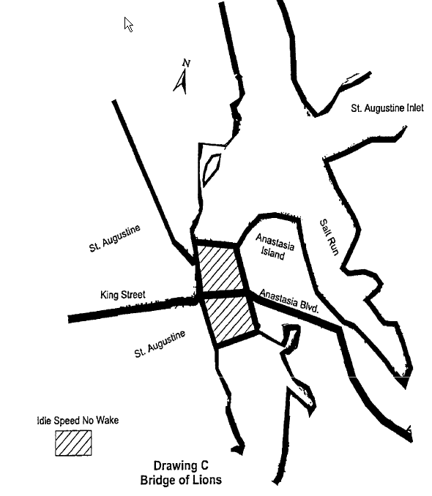

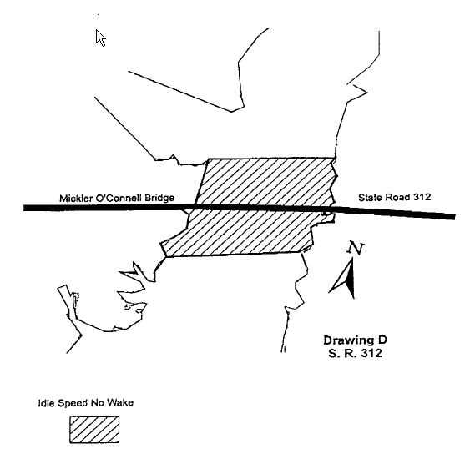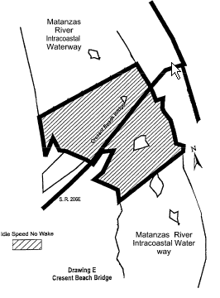

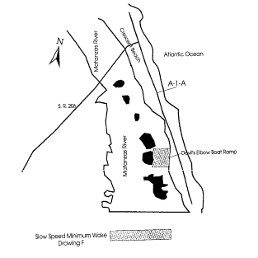
Specific Authority 327.04, 327.46 FS. Law Implemented 327.46 FS. History–New 12-11-97, Formerly 62N-24.155, Amended 11-14-01.

