61G1-16.002 Description of Seal.
(1) The seal shall contain the name of only one architect or interior designer and the registration number; the seal of the architect shall be circular, and the seal of the interior designer shall be hexagonal. Both seals shall be approximately 2” in diameter with two circular lines between which lines shall appear, at the top, the words “State of Florida” and at the bottom the words “registered architect” or “registered interior designer,” whichever is applicable. Seals stating “Licensed Interior Designer,” lawfully obtained by registered interior designers prior to January 1, 2015, may continue to be lawfully used.




(2) Any individual who is both a registered architect and a registered interior designer must use a seal which contains both the architect and interior design registration numbers, in such a manner:
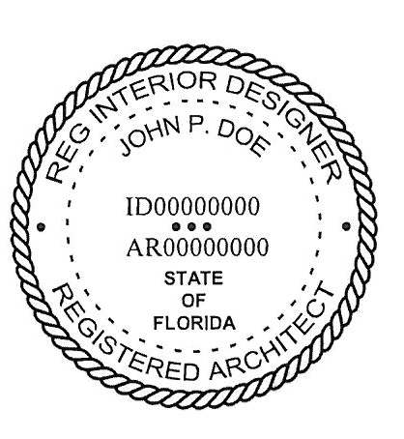

Rulemaking Authority 481.221 FS. Law Implemented 481.221 FS. History–New 12-23-79, Formerly 21B-16.02, Amended 7-27-89, Formerly 21B-16.002, Amended 1-16-07, 11-11-13, 3-22-15.

