Notice of Change/Withdrawal

DEPARTMENT OF ENVIRONMENTAL PROTECTION
RULE NOS.: RULE TITLES:
62-342.200 Definitions
62-342.700 Financial Responsibility
NOTICE OF CHANGE
Notice is hereby given that the following changes have been made to the proposed rule in accordance with Section 120.54(3)(d)1., F.S., published in Vol. 40, No. 117, June 17, 2014, issue of the Florida Administrative Register.
Forms 62-342.700(3), (4), (5) and (6) were also revised to reflect that the Investment Company Act of 1940, as amended, 15 U.S.C. 80a-1 et seq., is incorporated within Rule 62-342.700, and that the notary acknowledgment provided at the end of each of these forms is optional.

62-342.200 Definitions.
Terms used in this chapter shall have the meanings specified below.
(1) through (8) No change.
(9) “Regional Watershed” means a watershed as delineated in the following maps. (Figures 1, 2, 3, 4, and 5.)
Figure 1: Northwest Florida Water Management District ‒ “Regional Watersheds of the NWFWMD for Mitigation Banks, 7 Watersheds,” (effective date) (May 21, 2001), which is incorporated by reference herein.
Figure 2: Suwannee River Water Management District – “Watersheds of the SRWMD Mitigation Banks, 7 Watersheds,” (effective date) (May 21, 2001), which is incorporated by reference herein.
Figure 3 through Figure 5: No change.
A copy of the incorporated material identified above also may be obtained from the Agency Internet site or by contacting staff in an Agency office identified in the “References and Design Aids, Volume I”, available at http://www.dep.state.fl.us/water/rulesprog.htm#erp.
[Substituting the following map Figure 2, SRWMD, which includes the correct name of “Watershed V” as the Ocklawaha River Watershed:]
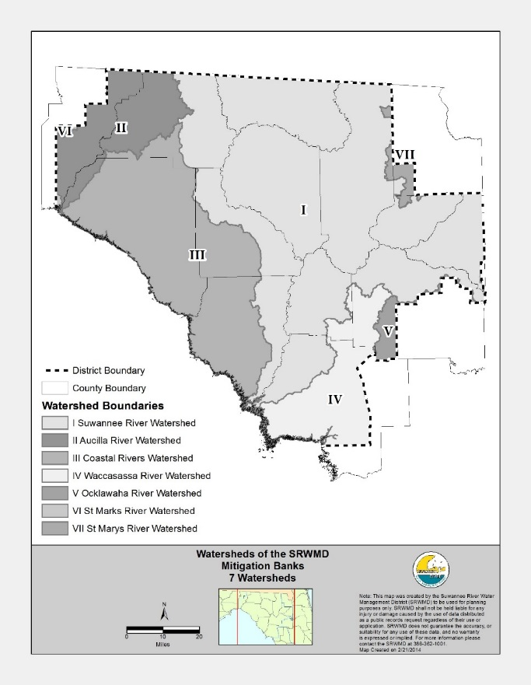
[Strike the following map published in the Notice of Proposed Rule because it incorrectly showed Watershed Boundary V as Peace River Watershed:]
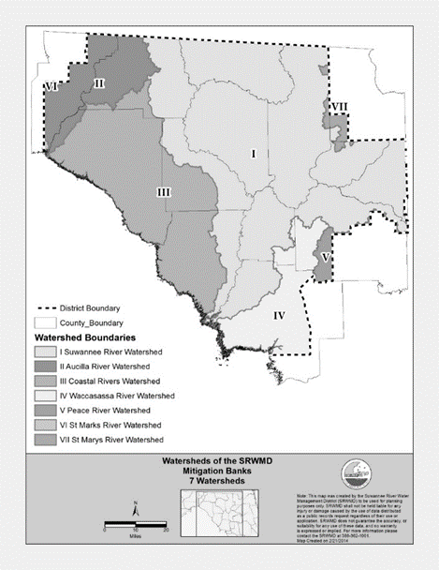
62-342.700 Financial Responsibility.
(1) through (4) No change.
(5) Surety or Performance Bond.
(a) No change.
(b) The surety or performance bond shall be worded in substantial conformance with Form 62-342.700(1), “Mitigation Bank Performance Bond to Demonstrate Construction and Implementation Financial Assurance,” (effective date) [May 21, 2001], which is incorporated by reference herein and available at http://www.flrules.org/Gateway/reference.asp?No=Ref-xxxxx. This form and all the forms incorporated in Rule 62-342.700, F.A.C., also are available from the Department of Environmental Protection’s Internet site, http://www.dep.state.fl.us/water/wetlands/erp/forms.htm; or by contacting the Submerged Lands and Environmental Resources Coordination Program, Department of Environmental Protection, 2600 Blair Stone Road—MS 2500, Tallahassee, Florida 32399, (850)245-8336. Deviations from the form shall be identified and submitted to the Agency for review and approval.
(c) through (f) No change.
(6) Irrevocable Letter of Credit.
(a) No change.
(b) The irrevocable letter of credit shall be worded in substantial conformance with Form 62-342.700(2), “Mitigation Bank Irrevocable Letter of Credit to Demonstrate Construction/Implementation Financial Assurance,” (effective date) (May 21, 2001) [available at (http://www.flrules.org/Gateway/reference.asp?No=Ref-xxxxx and as described in paragraph (5)(b) above]), incorporated by reference herein. Deviations from the form shall be identified and submitted to the Agency for review and approval.
(c) through (d) No change.
(7) Standby Trust Fund.
(a) No change.
(b) The standby trust agreement shall be worded in substantial conformance with Form 62-342.700(3), “Mitigation Bank Standby Trust Fund Agreement to Demonstrate Construction/Implementation Financial Assurance,” (effective date) (May 21, 2001) [available at (http://www.flrules.org/Gateway/reference.asp?No=Ref-xxxxx and as described in paragraph (5)(b) above]), incorporated by reference herein. Deviations from the form shall be identified and submitted to the Agency for review and approval. This form and Forms 62-342.700(4), 62-342.700(5) and 62-342.700(6), incorporated in Rule 62-342.700, F.A.C., reference the Investment Company Act of 1940, as amended, 15 U.S.C. 80a-1 et seq, (effective date), which is incorporated by reference herein (http://www.flrules.org/Gateway/reference.asp?No=Ref-xxxxx). A copy of the Act may also be obtained contacting the Submerged Lands and Environmental Resources Coordination Program, Department of Environmental Protection, 2600 Blair Stone Road—MS 2500, Tallahassee, Florida 32399, (850)245-8336.
(8) Trust Fund.
(a) No change.
(b) The trust agreement must be worded in substantial conformance to Form 62-342.700(4), “Mitigation Bank Trust Fund Agreement to Demonstrate Construction/Implementation Financial Assurance,” (effective date) (May 21, 2001) [available at (http://www.flrules.org/Gateway/reference.asp?No=Ref-xxxxx and as described in paragraph (5)(b) above]), incorporated by reference herein. Deviations from the form shall be identified and submitted to the Agency for review and approval.
(9) Financial Responsibility for Perpetual Management.
(a) A banker shall establish either a trust fund or an irrevocable letter of credit or surety or performance bond with a corresponding standby trust fund to provide financial responsibility for the perpetual management of the Mitigation Bank, or phase thereof. When a trust fund is used, the requirements of subsection 62-342.700(8), F.A.C., must be met. When a surety or performance bond or irrevocable letter of credit is used with a standby trust fund, the requirements of subsections 62-345.700(5), 62-342.700(6), and 62-342.700(7), F.A.C., respectively, must be met, except all references to construction and implementation shall be changed to perpetual management. Trust fund agreements for perpetual management shall be worded in substantial conformance with Form 62-342.700(5), “Mitigation Bank Trust Fund Agreement to Demonstrate Perpetual Management Financial Assurance,” (effective date) (May 21, 2001) [available at (http://www.flrules.org/Gateway/reference.asp?No=Ref-xxxxx and as described in paragraph (5)(b) above]), incorporated by reference herein. Standby trust fund agreements for perpetual management shall be worded in substantial conformance with Form 62-342.700(6) “Mitigation Bank Standby Trust Fund Agreement to Demonstrate Perpetual Management Financial Assurance (effective date) (May 21, 2001) [available at (http://www.flrules.org/Gateway/reference.asp?No=Ref-xxxxx and as described in paragraph (5)(b) above]), incorporated by reference herein. Deviations from the form shall be identified and submitted to the Agency for review and approval.
(b) through (c) No change.
(10) through (12) No change.

