1S-2.027 Standards for Determining Voter’s Choice on a Ballot.
(1) Application. The standards in this rule apply to determine whether the voter has clearly indicated a definite choice for purposes of counting a vote cast on a ballot in a manual recount as provided specifically by Section 102.166, F.S.
(2) Direct recording electronic voting system.
(a) A vote cast on this voting system is valid for a particular candidate, issue choice, or judicial retention choice when the voter marks the ballot electronically as specified in the ballot instructions.
(b) A vote cast on this voting system is valid for a particular write-in candidate when the voter types on the touch screen the name of a write-in candidate in accordance with the ballot instructions.
(3) Optical scan voting system.
(a) A vote cast on this voting system is valid for a particular candidate, issue choice, or judicial retention choice when the voter marks the ballot as specified in the ballot instructions.
(b) A vote cast on this voting system is valid for a particular write-in candidate when the voter writes in the name of a candidate in the designated write-in space and fills in the oval or arrow next to the write-in candidate’s name.
(4) Manual review and tabulation.
(a) The standards under this subsection apply in all instances where a contest is not marked as specified in the ballot instructions under subsection (2) or (3), and a manual review of the voter’s markings on a ballot is required to determine whether there is a clear indication that the voter has made a definite choice in a contest.
(b) The canvassing board must first look at the entire ballot for consistency. Then the provisions of paragraph (c) apply to determine whether the voter has made a definite choice in a contest, provided the voter has not marked any other contest on the ballot, or if the voter has marked other contests, he or she has marked them in the same manner, subject to the exceptions in subparagraphs 7., 10., and 15. The following are examples of valid votes after review for consistency:
Ballot Situation 1: Recount in race of State Representative. The two ovals in the first two races are filled in properly, but the voter has circled the candidate’s name in the state representative race. Since the voter did not mark the state representative race in the same manner as in the other races, it cannot be determined whether the voter has clearly indicated a definite choice for Don Nichols.

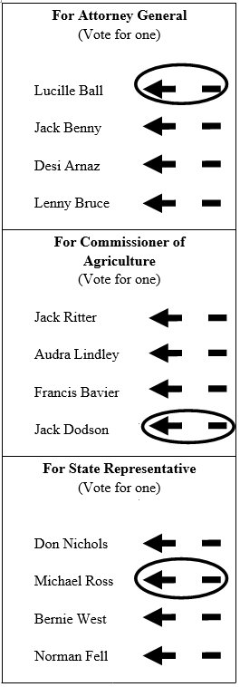 | Ballot Situation 2: Recount in race of State Representative. All races on this ballot are marked in the same manner. Since the ballot is consistently marked as in paragraph (c), the vote cast for Michael Ross in the state representative race is a valid vote.

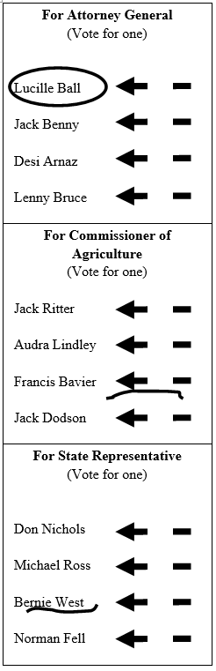 | Ballot Situation 3: Recount in State Representative race. Each race is marked differently so that no consistency in marking exists. It cannot be determined which marking, if any, is clearly indicative of the voter’s choice. Therefore, the vote cast for Bernie West is not valid.

(c) Subject to the provisions of paragraph (4)(b), the following marks constitute a valid vote as indicated for a particular candidate, issue choice, or judicial retention choice:
1. The voter circles or underlines either the oval or arrow next to a candidate’s name, issue choice, or judicial retention choice.
Valid Vote for Ball |  | Valid Vote for Ball
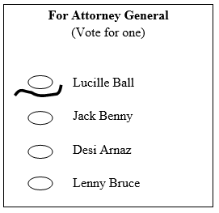 |  | 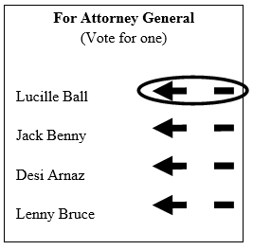
Valid Vote for Ball |  | Valid Vote for Ball
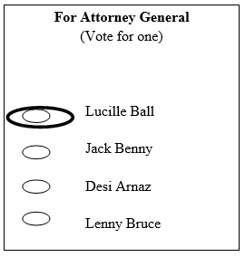 |  | 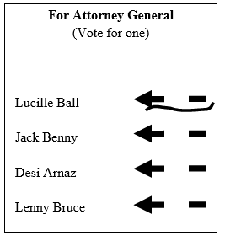

2. The voter circles or underlines the name of a candidate, issue choice, or judicial retention choice.
Valid Vote for Arnaz |  | Valid Vote for Arnaz
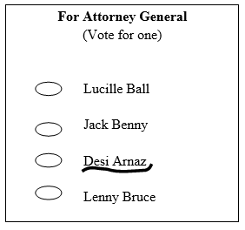 |  | 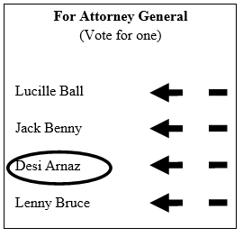

3. The voter circles or underlines the party abbreviation associated with a candidate’s name.
Valid Vote for Benny |  | Valid Vote for Benny
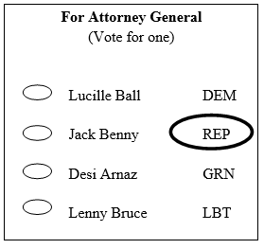 |  | 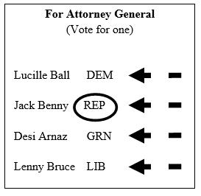
4. The voter marks an “X,” a check mark, a cross, a plus sign, an asterisk or a star, any portion of which is contained in a single oval or within the blank space between the head and tail of a single arrow. The marking must not enter into another oval or the space between the head and tail of another arrow.
Valid Vote for Ball |  | Valid Vote for Ball
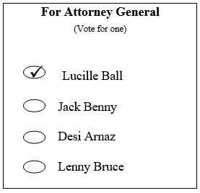 |  | 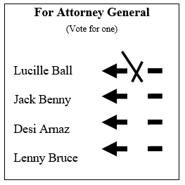
Invalid Vote |  | Invalid Vote
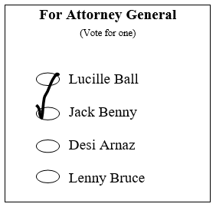 |  | 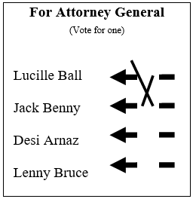

5. The voter draws a diagonal, horizontal, or vertical line, any portion of which intersects two points on the oval and which does not intersect another oval at any two points. If it is a horizontal line, the line must not strike through the name of the candidate.
Valid Vote for Ball |  | Valid Vote for Ball
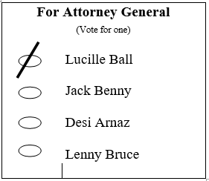 |  | 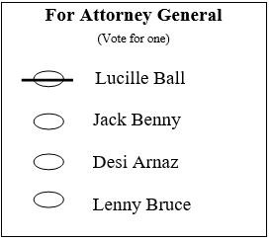
Invalid Vote |  | Invalid Vote
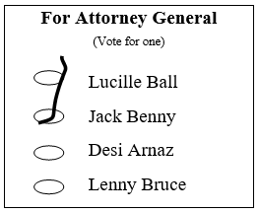 |  | 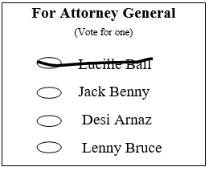

6. The voter draws a diagonal or vertical line that intersects an imaginary line extending from the center of the head of a single arrow to the center of the tail of the same arrow, provided the diagonal or vertical line does not intersect the imaginary line joining the head and tail of another arrow.
Valid Vote for Ball |  | Invalid Vote
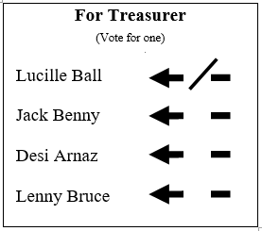 |  | 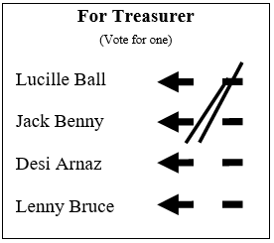

7. The voter marks all the choices for a race but further clarifies a choice for a particular candidate, issue choice or judicial retention choice by placing an additional mark or marks showing support solely for that particular candidate, issue or judicial retention choice.
Valid Vote for Arnaz |  | Valid Vote for Ball
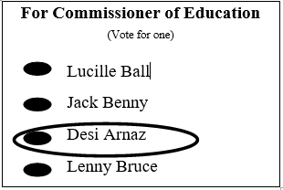 |  | 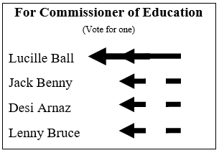

Valid Vote to Keep Justice in Office
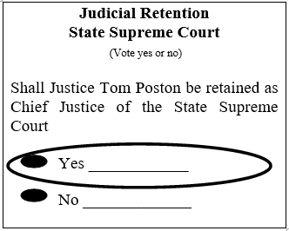

8. The voter strikes through all the choices for candidates, issue, or judicial retention except for one and also leaves the write-in candidate space blank.
Valid Vote for Bruce
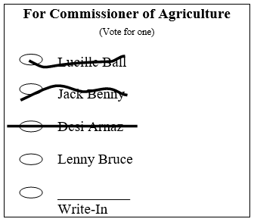

9. The voter writes words such as “Vote for [candidate’s name],” “Count this vote” or “Vote no on amendment or referendum,” or “I want this one,” provided there are no other markings in the race that would constitute a valid vote for a different candidate, issue choice, or judicial retention choice pursuant to rule.

Valid Vote for Arnaz |  | Invalid Vote
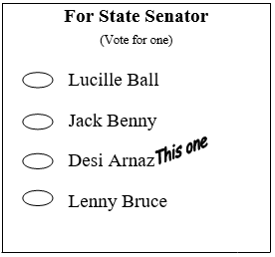 |  | 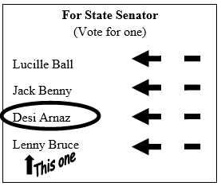

Valid “No” vote
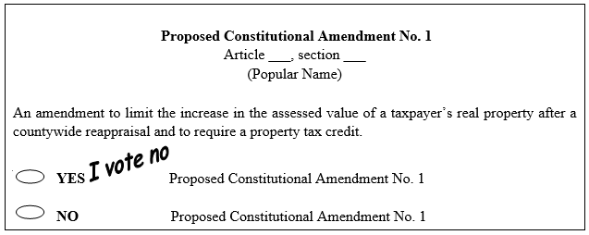

10. The voter fills in the majority of an oval, or the majority of the distance between the head and the tail of an arrow designating a particular candidate, issue choice, or judicial retention choice, regardless of how other races on the ballot are marked.
Valid Vote for Arnaz |  | Valid Vote for Arnaz
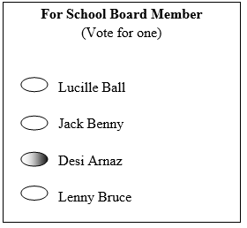 |  | 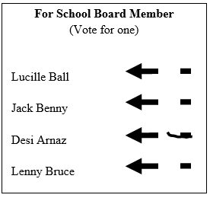

11. If a voter marks fewer candidates than there are positions to be elected for those offices, then the votes for all of those marked candidates shall count. For example, if the voter is allowed to vote for 5 candidates in a special district election (“Vote for 5”) and the voter marks 2 candidates, the votes for those two marked candidates shall count.
Valid Votes for Arnaz and Bruce |  | Valid Vote for Benny
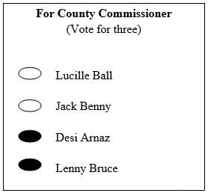 |  | 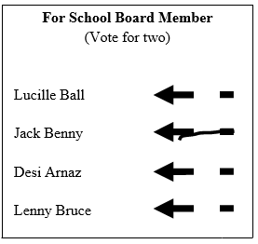

12. The voter draws an arrow from the arrow head to a particular candidate, issue choice or judicial retention choice or draws an arrow head on the tail end of the arrow in lieu of filling in the void between the arrow head and the tail for the particular candidate, issue choice or judicial retention choice.
Valid Vote for Arnaz |  | Valid Vote for Bruce
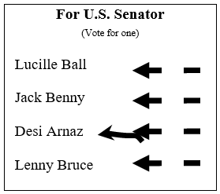 |  | 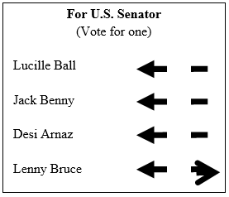

13. The voter darkens or bolds the arrow head and the arrow tail but does not fill in the void between the arrow head and the tail.
Valid Vote for Ball
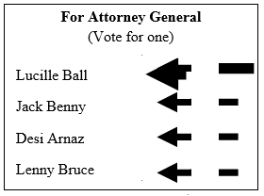

14. The voter punches the oval or the void between the arrow head and tail.
Valid Vote for Ball |  | Valid Vote for Benny
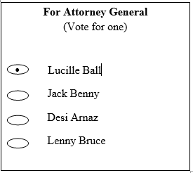 |  | 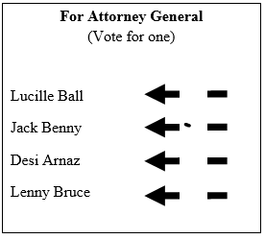

15. The voter marks two or more choices similarly in one of the ways indicated in paragraphs 1.-14. and additionally writes in comments such as “not this,” “ignore this,” “don’t want,” or “wrong,” or “Vote for [candidate’s name]” such that voter’s definite choice is clearly indicated.
Valid Vote for Ball |  | Valid Vote for Arnaz
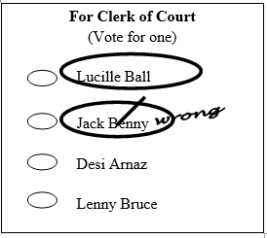 |  | 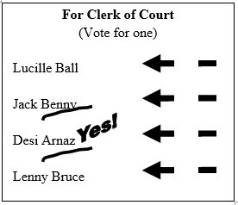

(5) Write-in Voting.
(a) A voter is determined to have made a definite choice for a write-in vote for the joint office of President/Vice-President if the voter writes in either the last name of the candidate for President or the last name of the candidate for Vice-President. This standard similarly applies to constitute a valid write-in vote for the joint office of Governor/Lieutenant Governor if the voter writes in either the last name of the candidate for Governor or the last name of the candidate for Lieutenant Governor.
Valid Vote for Joint Qualified Write-in President and Vice President Candidates, Lenny Bruce and Sally Marr
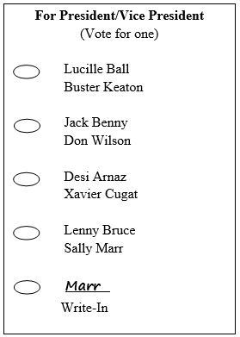

(b) A voter is determined to have made a definite choice for a named candidate if the voter indicates a vote for a candidate named on the ballot and also writes-in the name of that same candidate in the blank space for ‘write-in candidate’.
Valid Vote for Benny
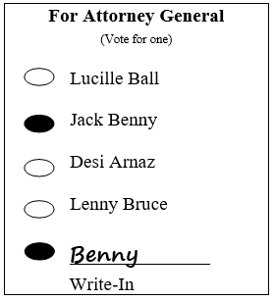

(c) A voter is determined to have made a definite choice for a particular candidate if the voter either writes in the name of a qualified write-in candidate or the name of a candidate who is named on the ballot in that race, whether or not the oval or arrow designating the selection of a write-in candidate has been marked.
Valid Vote for Smith, if Smith  is a qualified write-in candidate |  | Valid Vote for Bruce
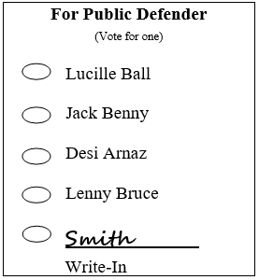 |  | 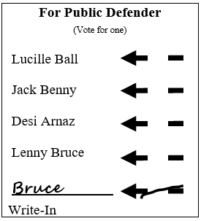

(d) If a voter abbreviates, misspells or varies the form of the name of a candidate in the write-in candidate space, it shall not affect the determination of whether the voter has made a definite choice.

Kelly BarwickW Pty
James CarlisleY Pty
Florence DavisZ Pty
Doria MoodyWW Pty
Glen SaltmanYY Pty
David WarrenZZ Pty
_Saltman_________________
(Write-In Candidate)
Vote to be counted for: Saltman
Official General Election Ballot

Tallahassee, Florida Date

Attorney General
(Vote for one)

□Kelly BarwickW Pty
□James CarlisleY Pty
□Florence DavisZ Pty
□Doria MoodyWW Pty
□Glen SaltmanYY Pty
□David WarrenZZ Pty
□__Moody_________________(Write-In Candidate)
Vote to be counted for: Moody
Official General Election Ballot

Tallahassee, Florida Date

Attorney General
(Vote for one)

○Kelly BarwickW Pty
○James CarlisleY Pty
○Florence DavisZ Pty
○Doria MoodyWW Pty
○Glen SaltmanYY Pty
○David WarrenZZ Pty
○_Bob Smith (Write-In Candidate)
Vote to be counted for: Bob Smith *
Official General Election Ballot

Tallahassee, Florida Date

Attorney General
(Vote for one)

* If Bob Smith is a qualified write-in candidate.
(e) If a voter indicates a vote for a candidate named on the ballot and also writes in a name of a different person in the write-in candidate space, it shall be considered an overvote and none of the votes are valid for that race.
For Attorney General
(Vote for one)
□ Lucille Ball W Pty
□ Jack Benny Y Pty
□ Desi Arnaz Z Pty
□ Lenny Bruce WW Pty
□ Kelly Barwick
(Write In Candidate)

Invalid Vote |  | Invalid Vote
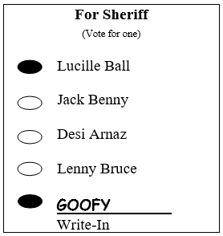 |  | 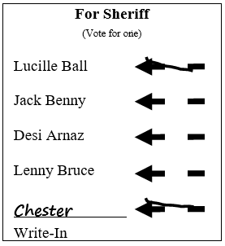

(6) Overvotes. Except as otherwise provided in subsections (4) and (5), if the voter marks more choices than there are positions or choices for that office or issue, it shall be considered an overvote and none of the votes are valid for that race.
Invalid Vote |  | Invalid Vote
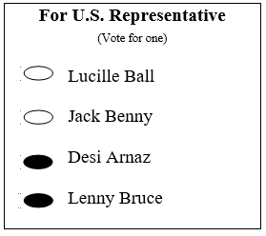 |  | 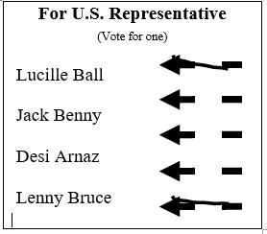

(7) Valid Vote.

□Kelly BarwickW Pty
■James CarlisleY Pty
□Florence DavisZ Pty
■Doria MoodyWW Pty
□Glen SaltmanYY Pty
□David WarrenZZ Pty
□__________________________(Write-In Candidate)
Official General Election Ballot

Tallahassee, Florida Date

Attorney General
(Vote for one)

●Kelly BarwickW Pty
○James CarlisleY Pty
○Florence DavisZ Pty
○Doria MoodyWW Pty
○Glen SaltmanYY Pty
●David WarrenZZ Pty
○__________________________(Write-In Candidate)
Vote to be counted for: NO VOTE
Official General Election Ballot

Tallahassee, Florida Date

Attorney General
(Vote for one)

Kelly BarwickW Pty
James CarlisleY Pty
Florence DavisZ Pty
Doria MoodyWW Pty
Glen SaltmanYY Pty
David WarrenZZ Pty
__________________________
(Write-In Candidate)
Vote to be counted for: NO VOTE
Official General Election Ballot

Tallahassee, Florida Date

Attorney General
(Vote for one)

(a) A vote shall not count for any particular candidate, issue choice, or judicial retention choice at issue unless determined to be a valid vote pursuant to this rule.
(b) If a voter does not mark a candidate, judicial retention choice, or issue choice in a contest, the valid votes for other candidates or issues on the same ballot shall still be counted.
Rulemaking Authority 20.10(3), 97.021, 102.166(4) FS. Law Implemented 101.5614(5), 102.166(4), FS. History–New 6-6-02, Amended 10-6-08.

